Animal-Care Veterinary Clinic III
Presented To Houria houmel
PART III
PRESENTED BY : JIMENA MARIN, SOFIA GUERRA, DAVID MOLANO, JUAN PABLO MONROY
2025
Contents
0
TABLES 3
Administrators 3
Create 3
Edit 4
Details 4
Delete 5
Receptionist 6
Create 6
Edit 7
Details 7
Delete 8
Veterinarians 9
Create 9
Edit 10
Details 10
Delete 11
Owners 12
Create 12
Edit 13
Details 13
Delete 14
Pets 15
Create 15
Edit 16
Details 16
Delete 17
Appointments 18
Create 18
Edit 19
Details 19
Delete 20
Clinical History 21
Create 21
Edit 22
Details 22
Delete 23
VIEWS 24
View All Users 24
Appointments Agenda 25
Monthly vet's workload 26
Clinic History 27
Slots Available 28
PROCEDURES 29
New appointment validation 29
Cancel appointment 30
Monthly report 30
TRIGGERS 31
Prevent Past Appointments 31
Cancel future appointments 32
Cancel appointments after delete veterinarian 33
Delete clinical history after delete pet 34

TABLES

Administrators
This table displays all the users with the role of administrators:
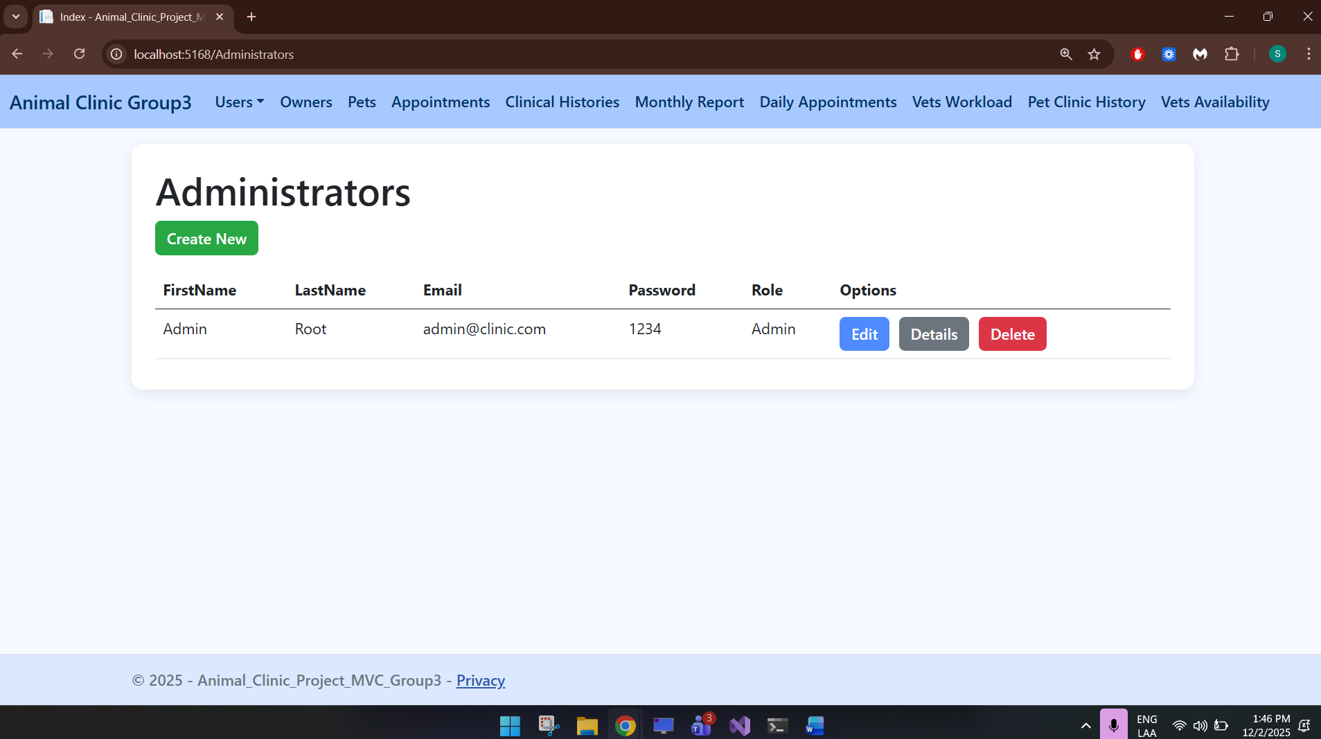

Create
By clicking on create new, a create administrator screen will open:
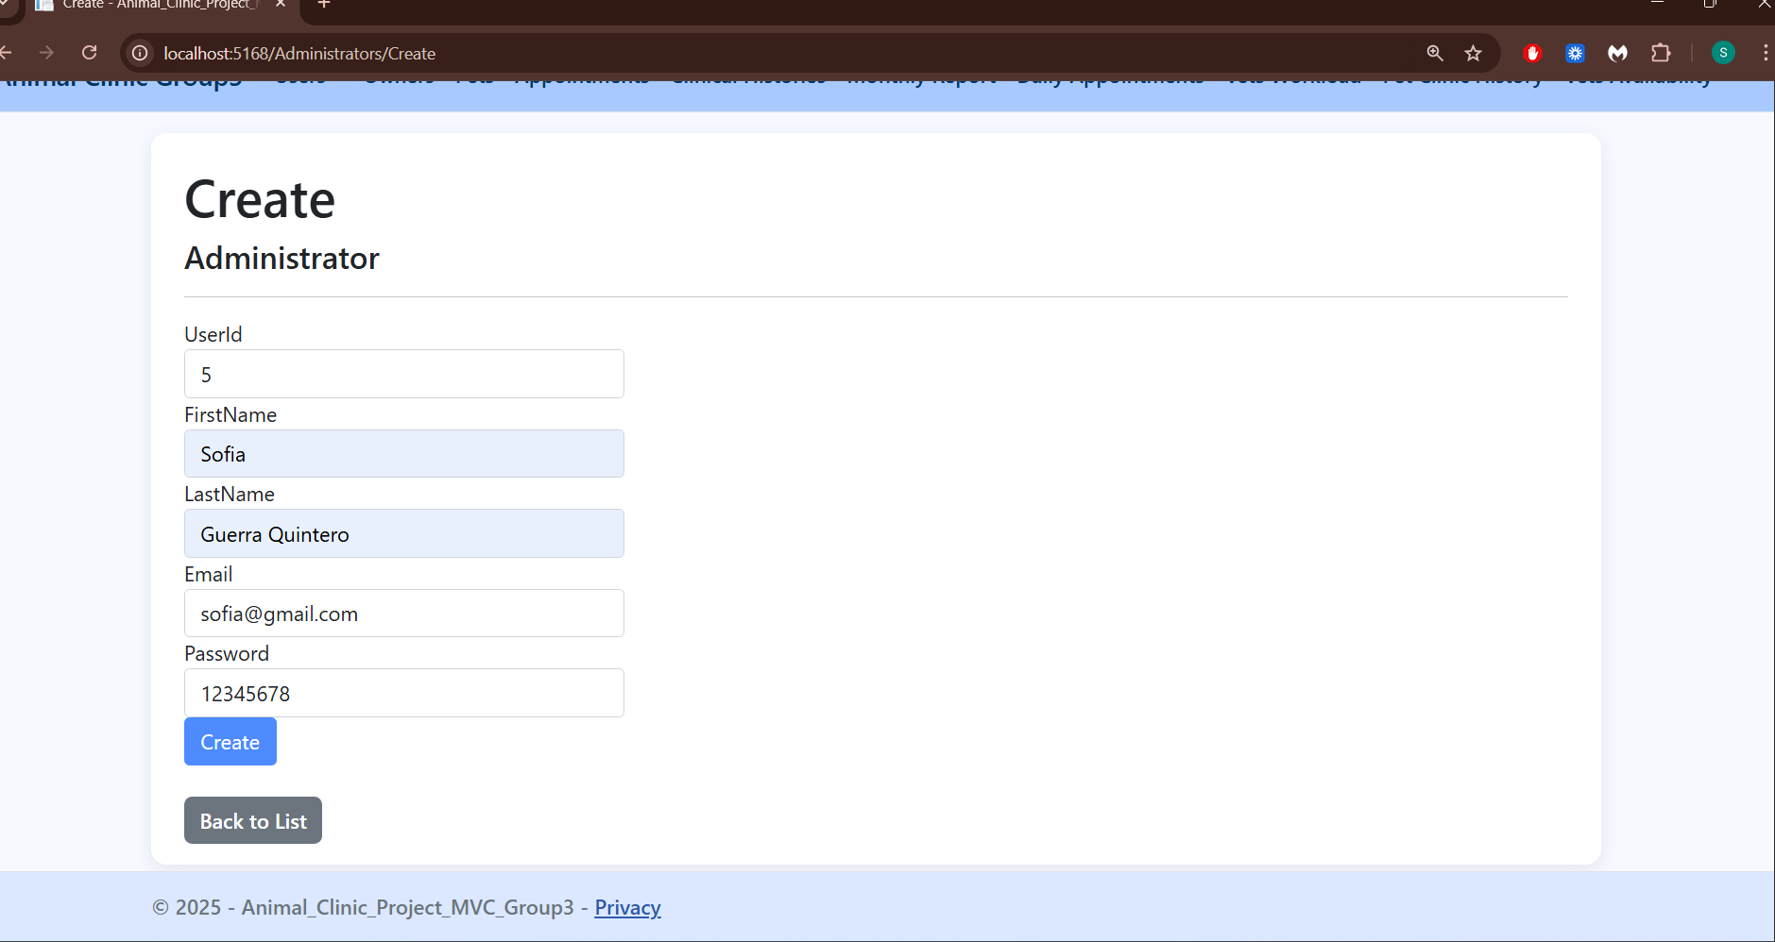

Edit
By clicking on Edit, a edit administrator screen will open:
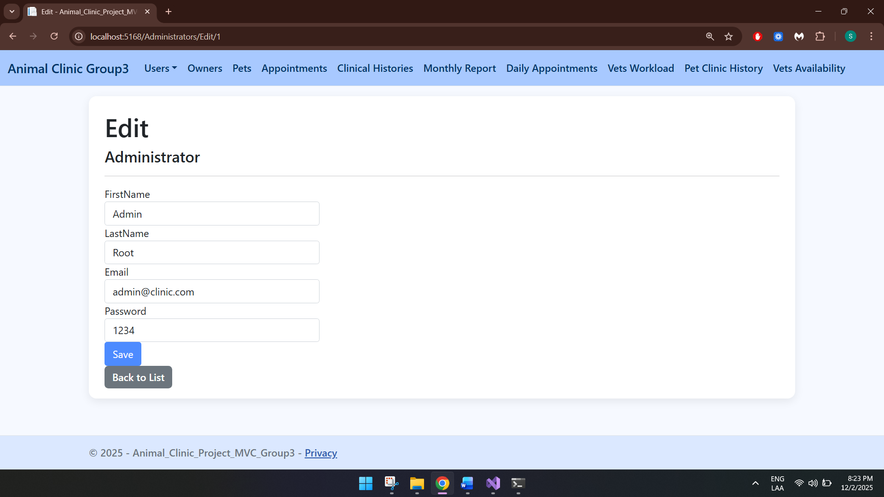

Details
By clicking on Details, a details screen will open:
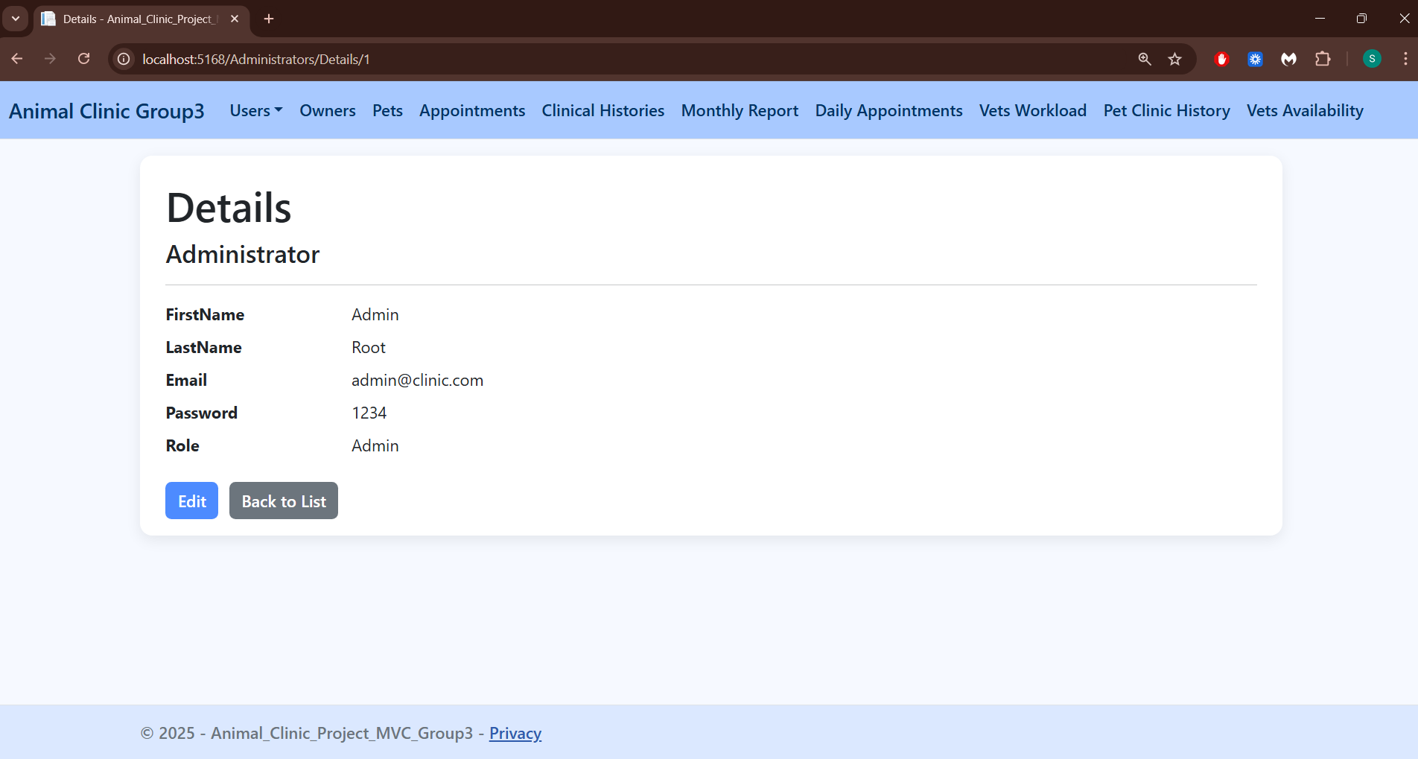

Delete
By clicking on Delete, a delete screen will open:
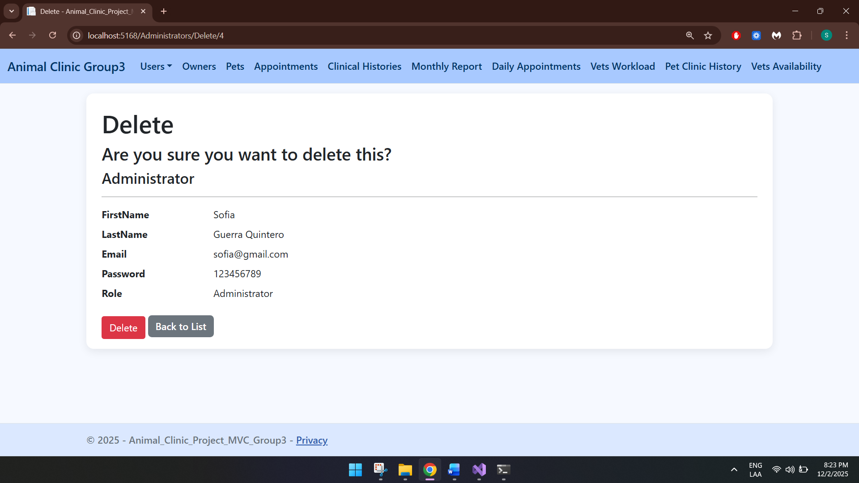

Receptionist
This table displays all the users with the role of receptionist:
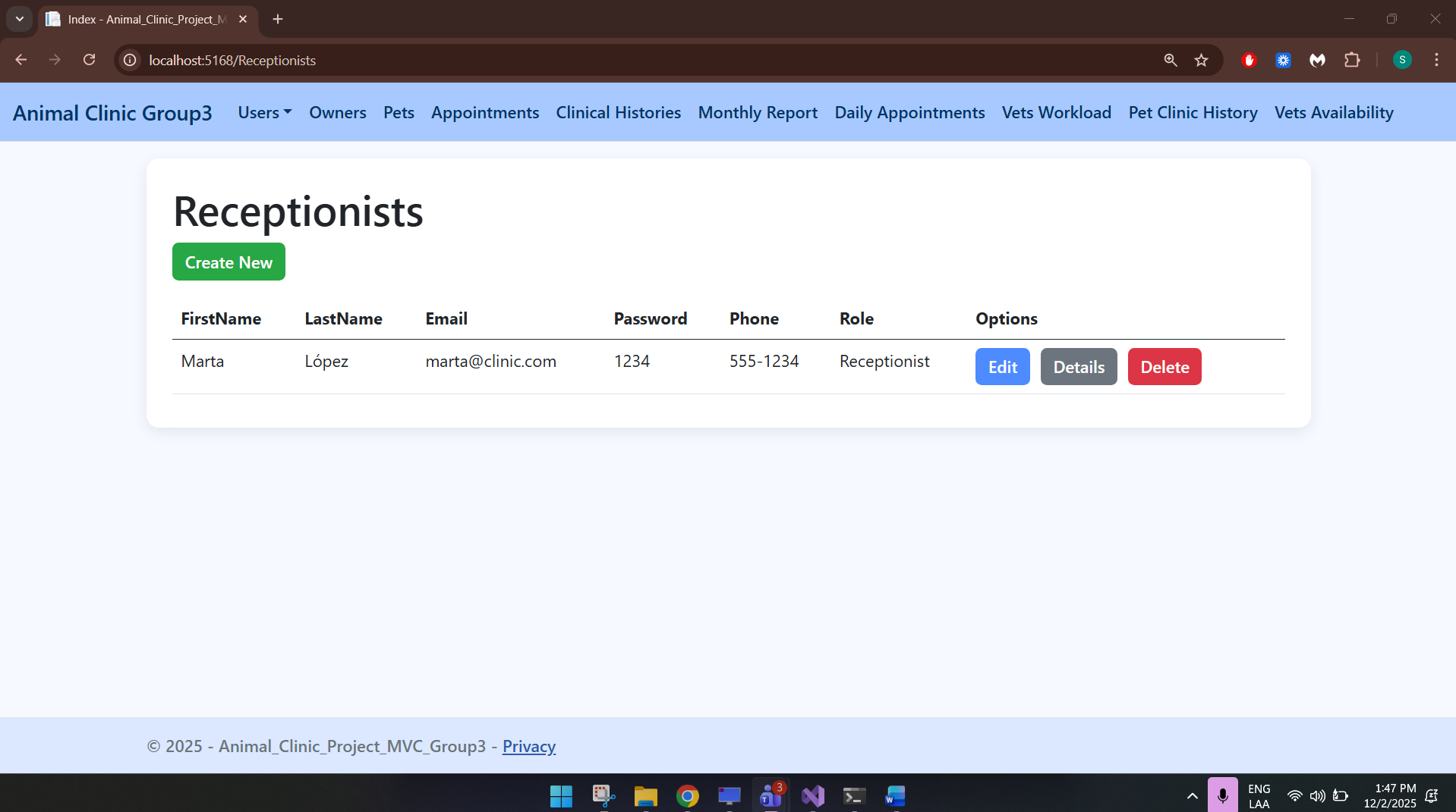

Create
By clicking on create new, a create receptionist screen will open:
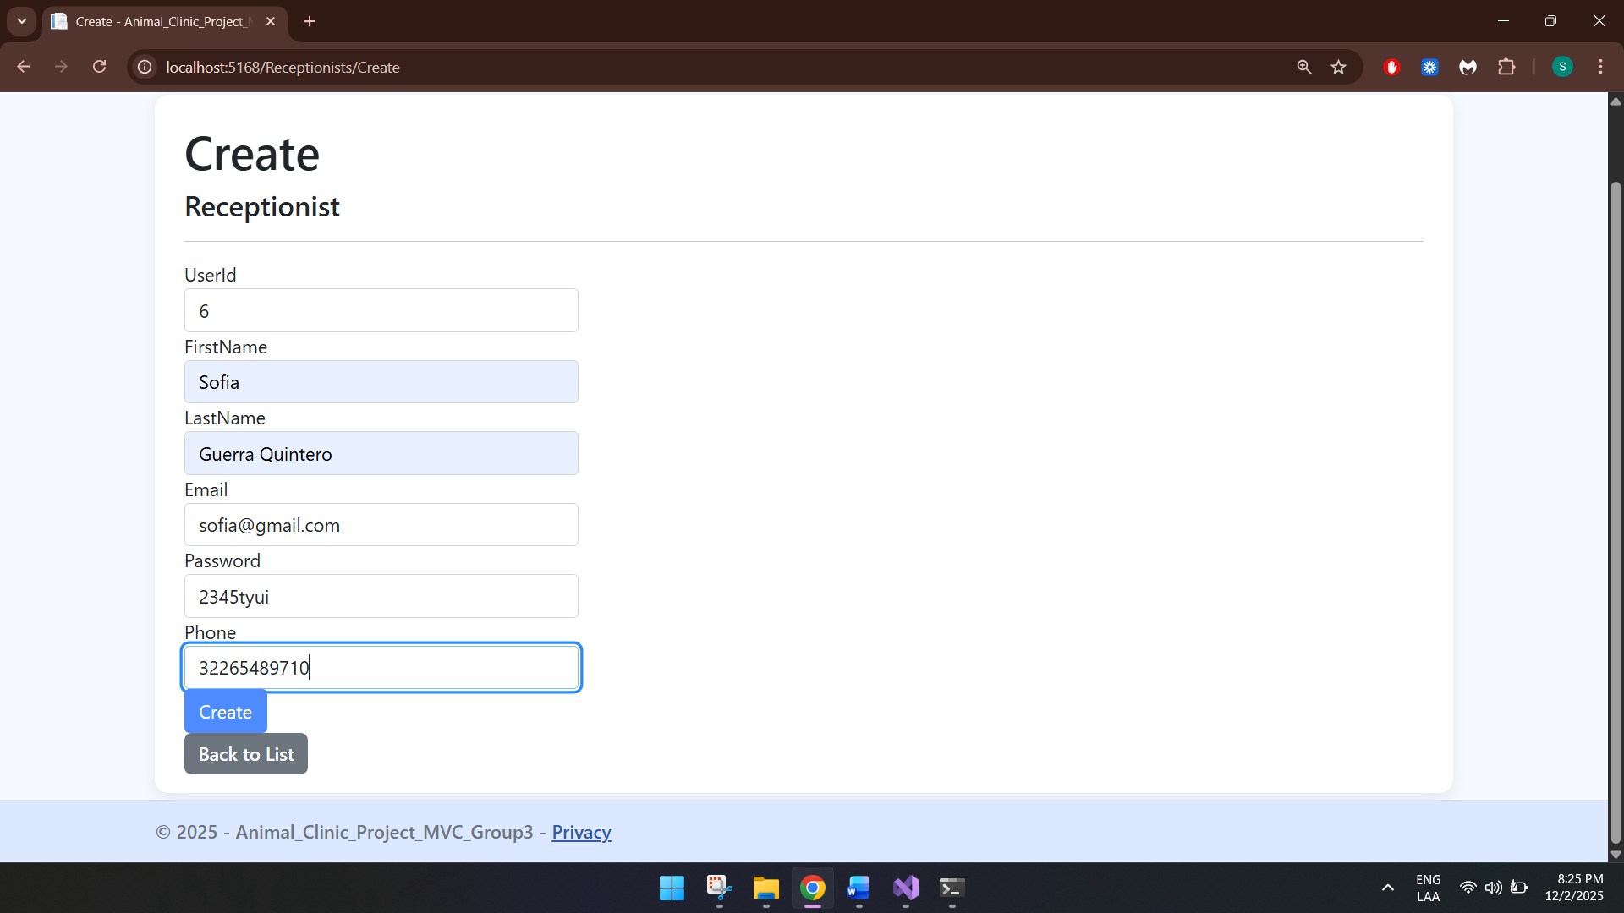

Edit
By clicking on Edit, a edit receptionist screen will open:
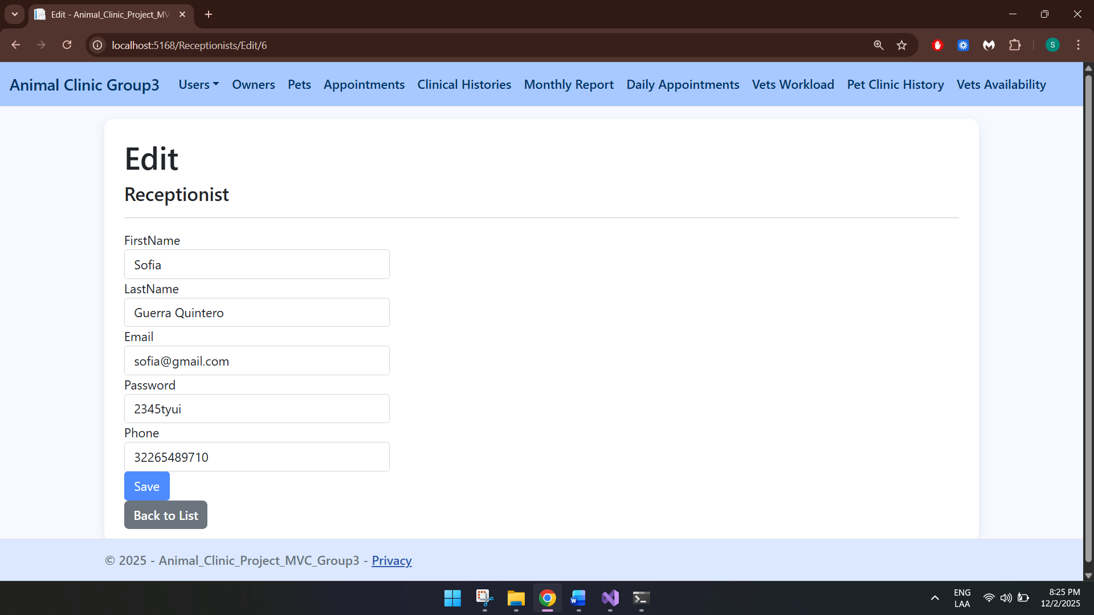

Details
By clicking on Details, a details screen will open:
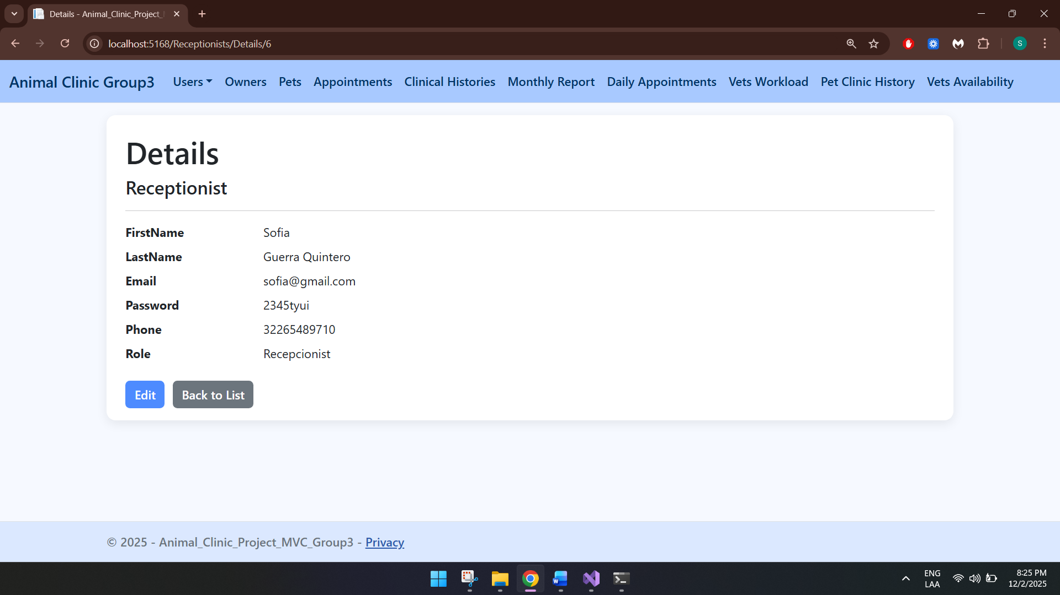

Delete
By clicking on Delete, a delete screen will open:
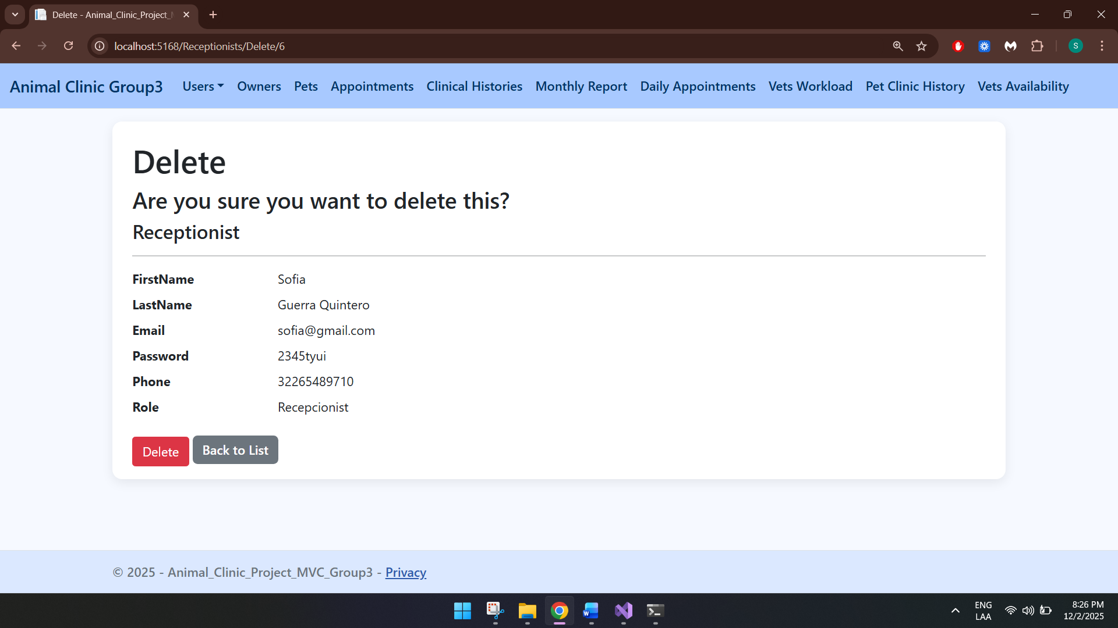

Veterinarians
This table displays all the users with the role of veterinarians:
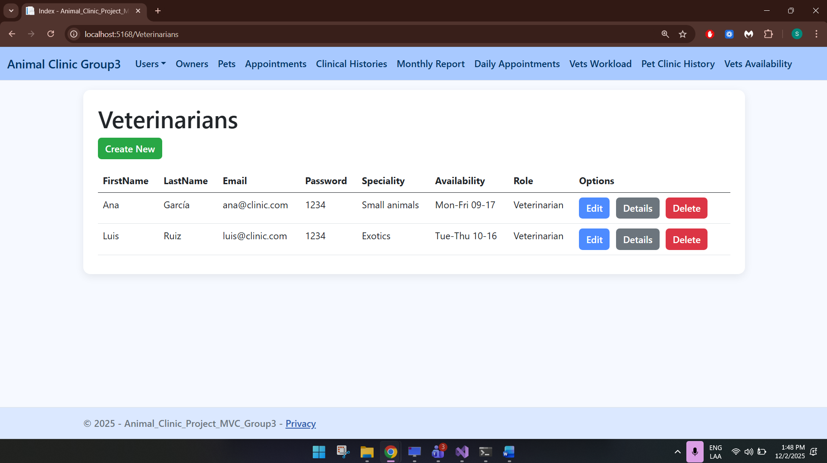

Create
By clicking on create new, a create administrator veterinarians will open:
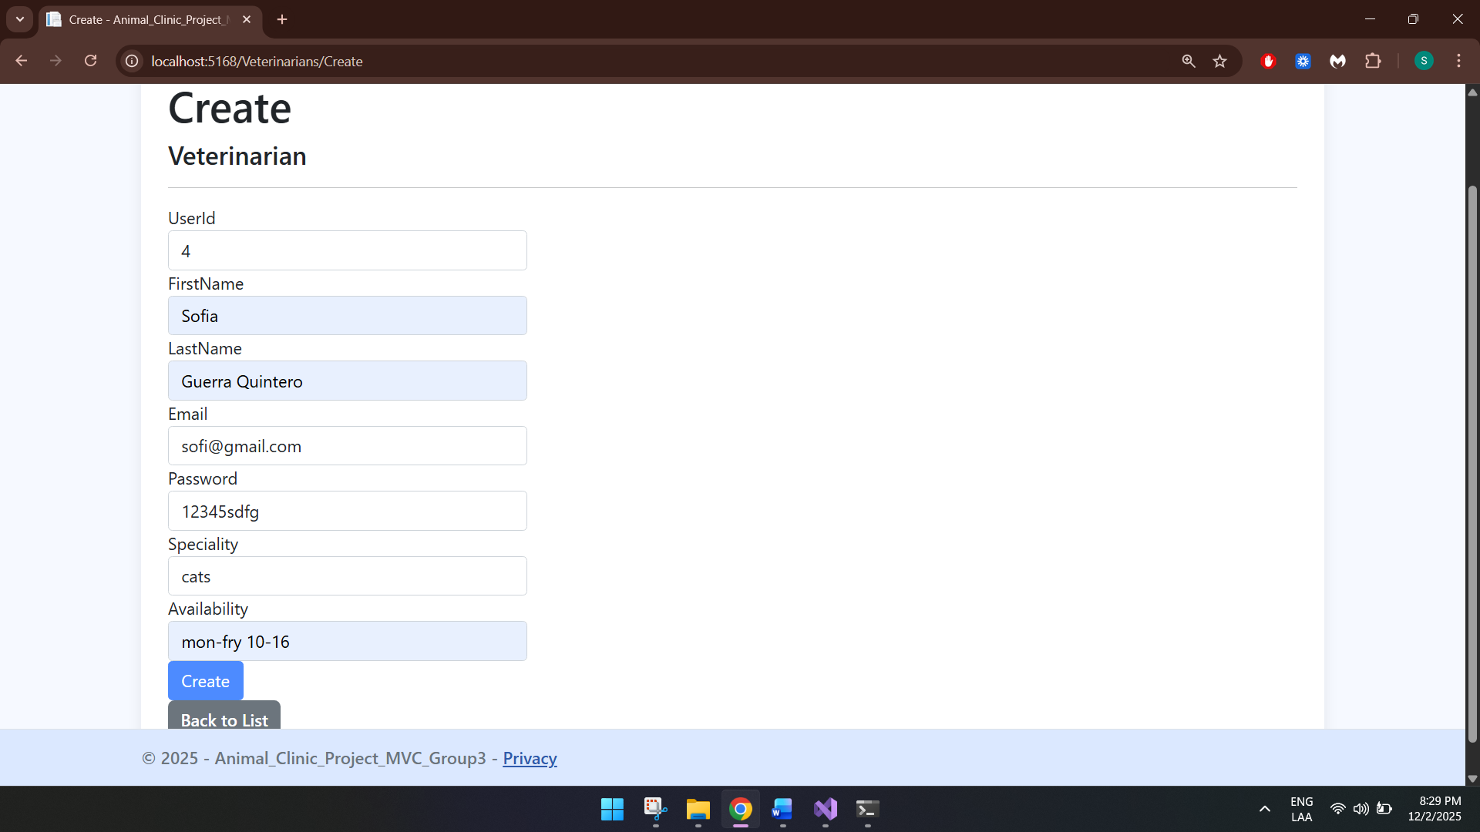

Edit
By clicking on Edit, a edit veterinarian screen will open:
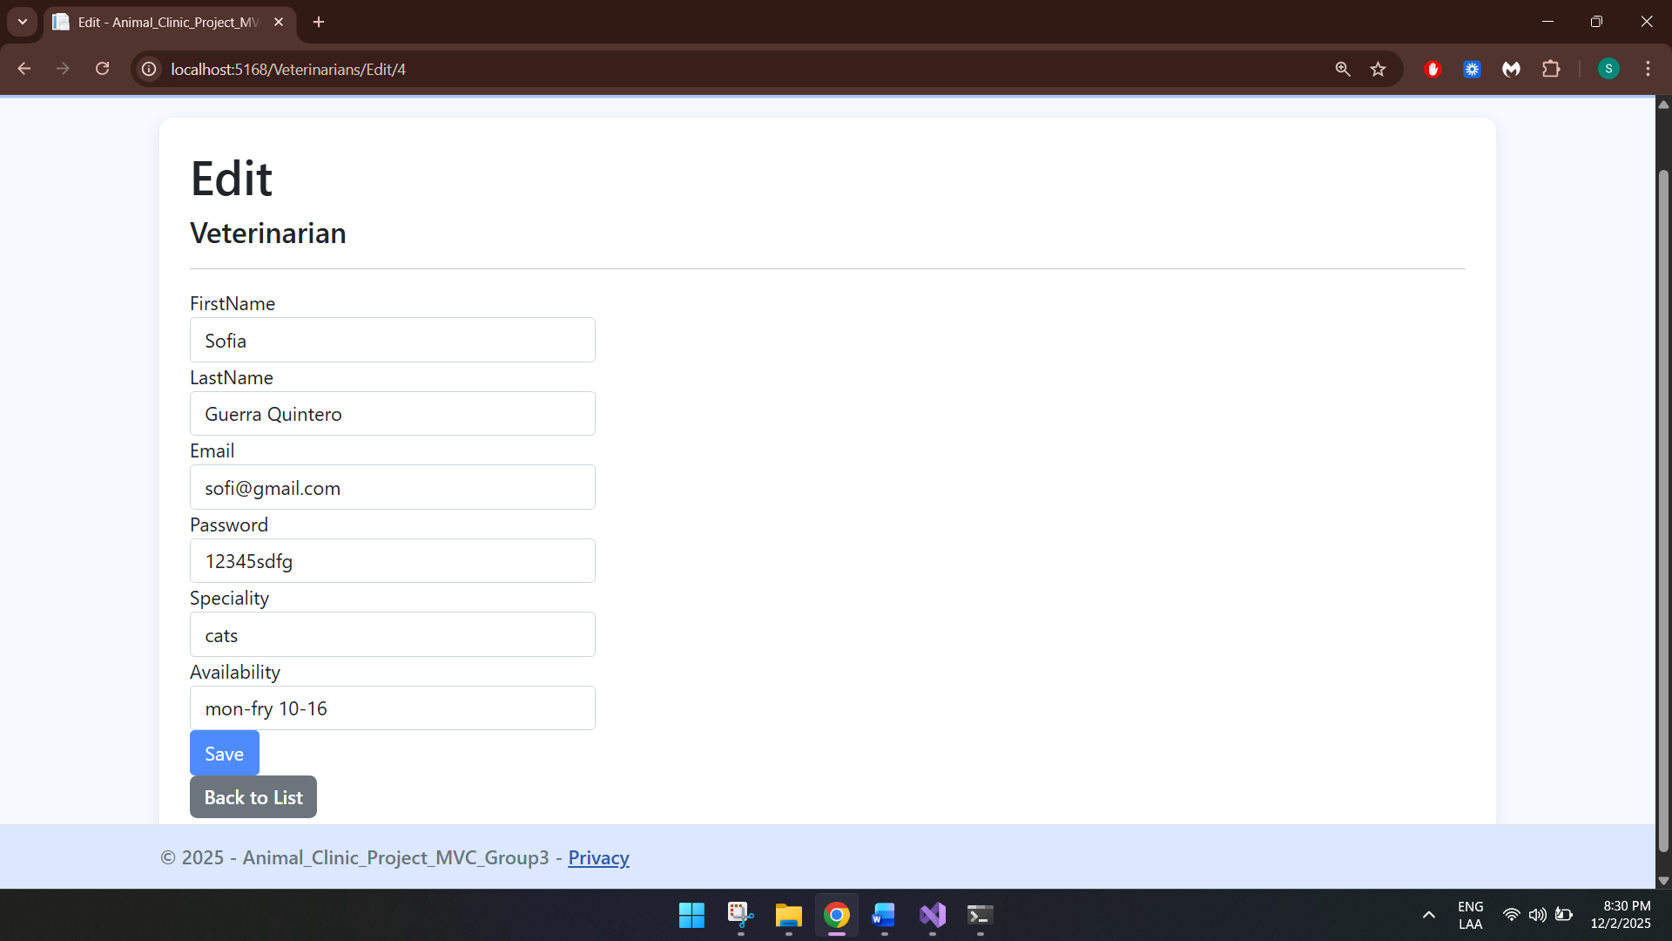

Details
By clicking on Details, a details screen will open:
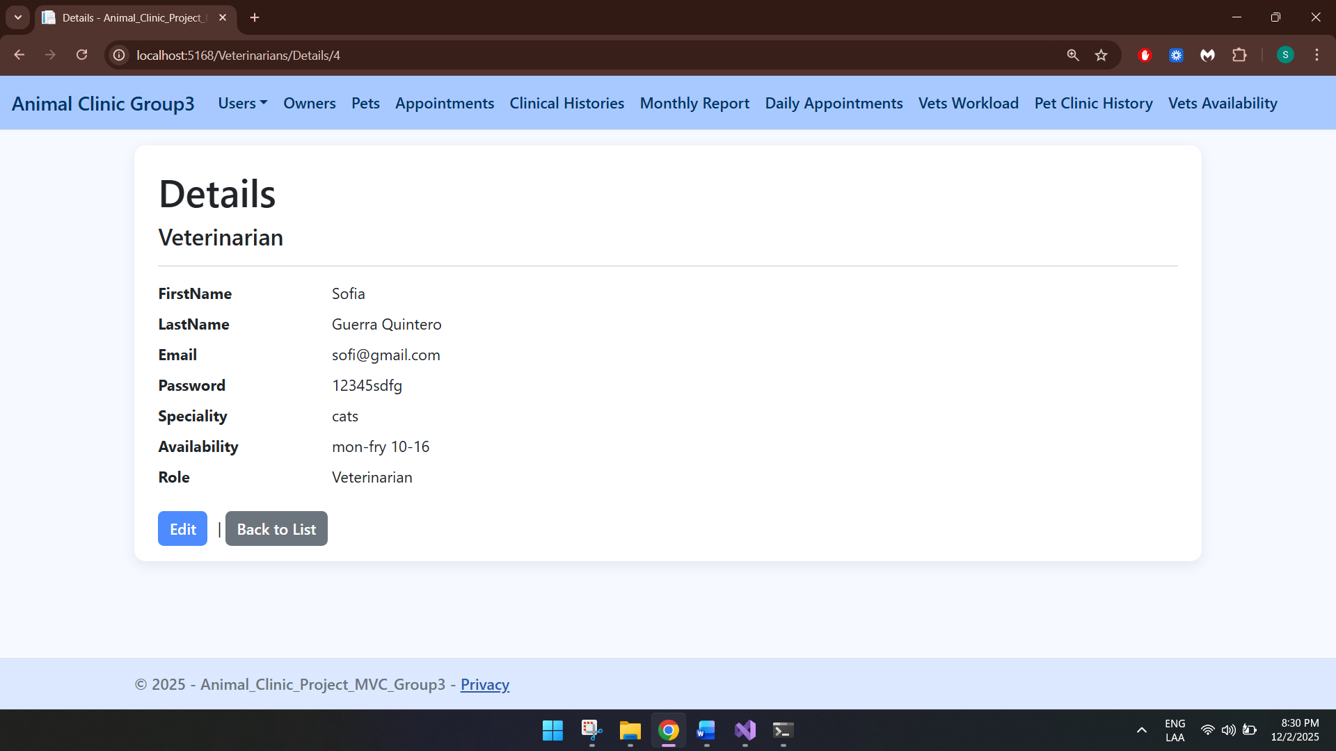

Delete
By clicking pn Delete, a delete screen will open:
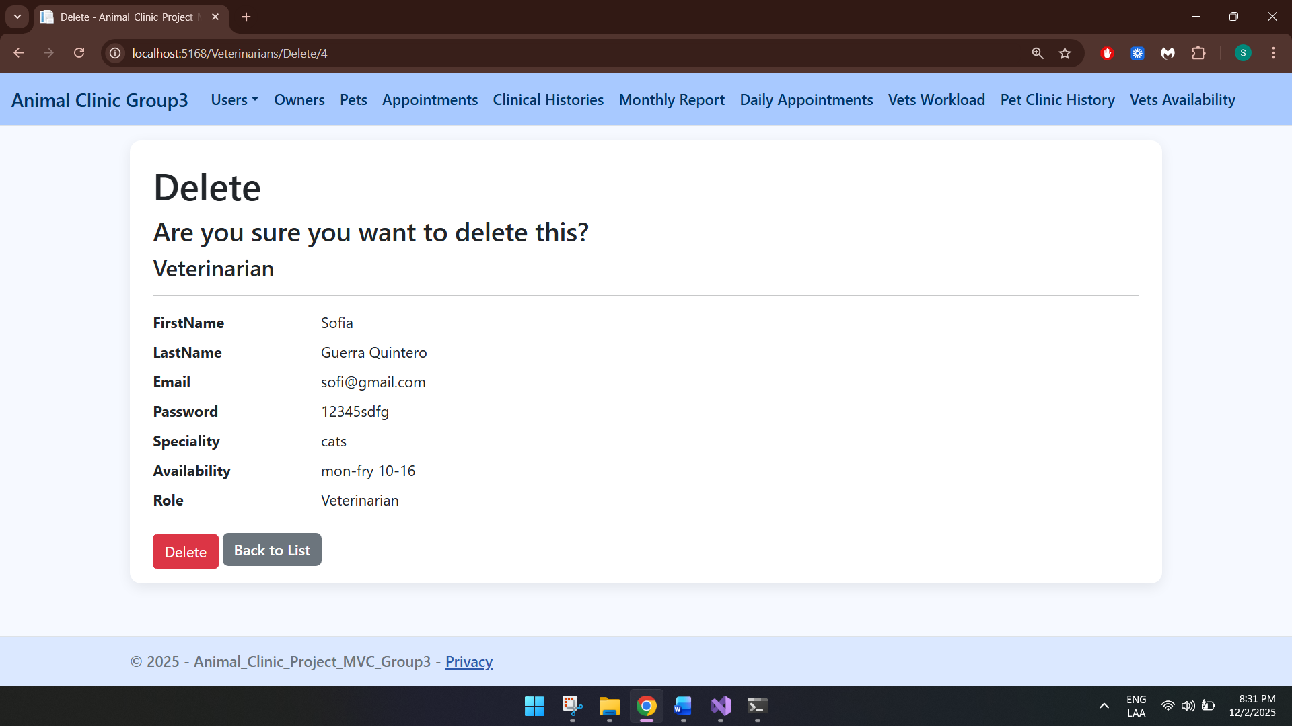

Owners
This table displays all the users with the role of owners:
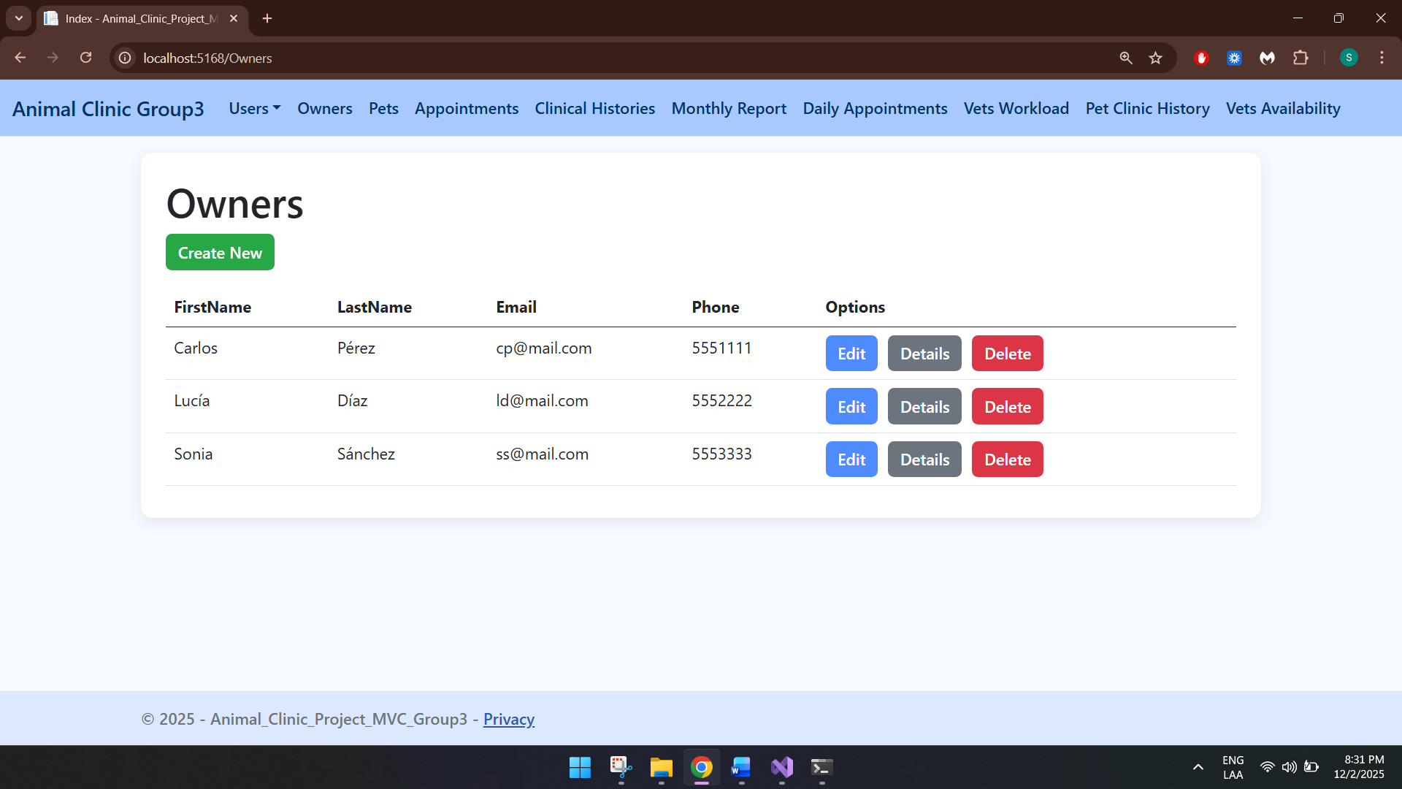

Create
By clicking on create new, a create owner screen will open:
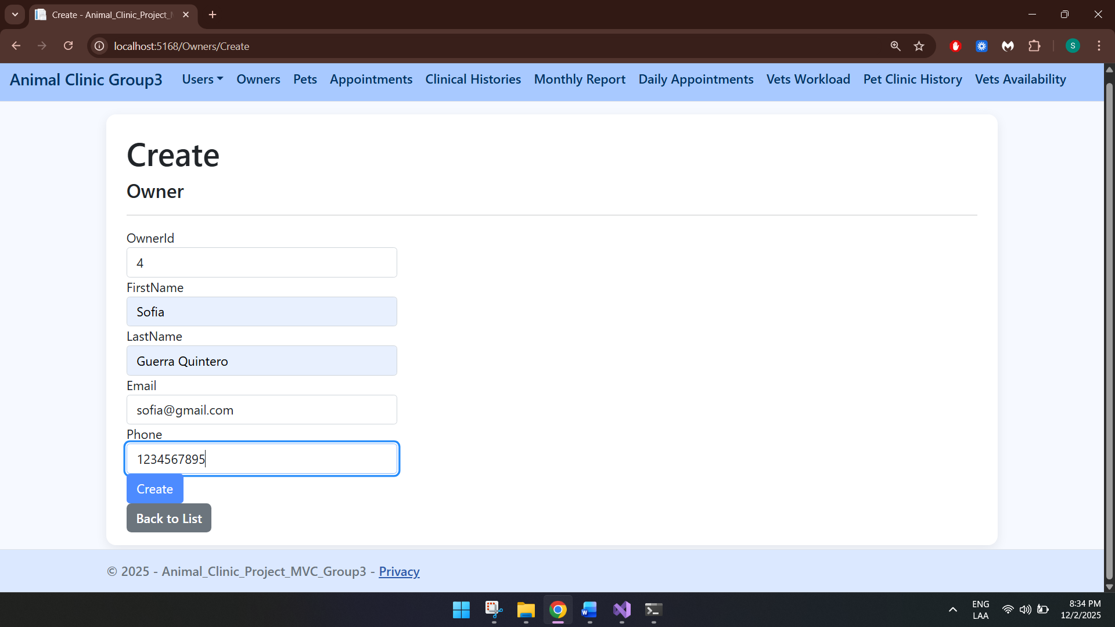

Edit
By clicking on Edit, a edit owner screen will open:
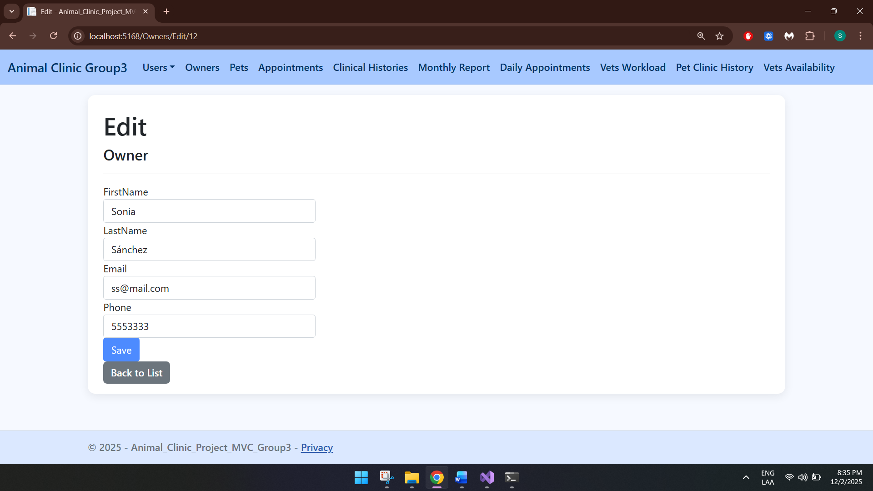

Details
By clicking on Details, a details screen will open:
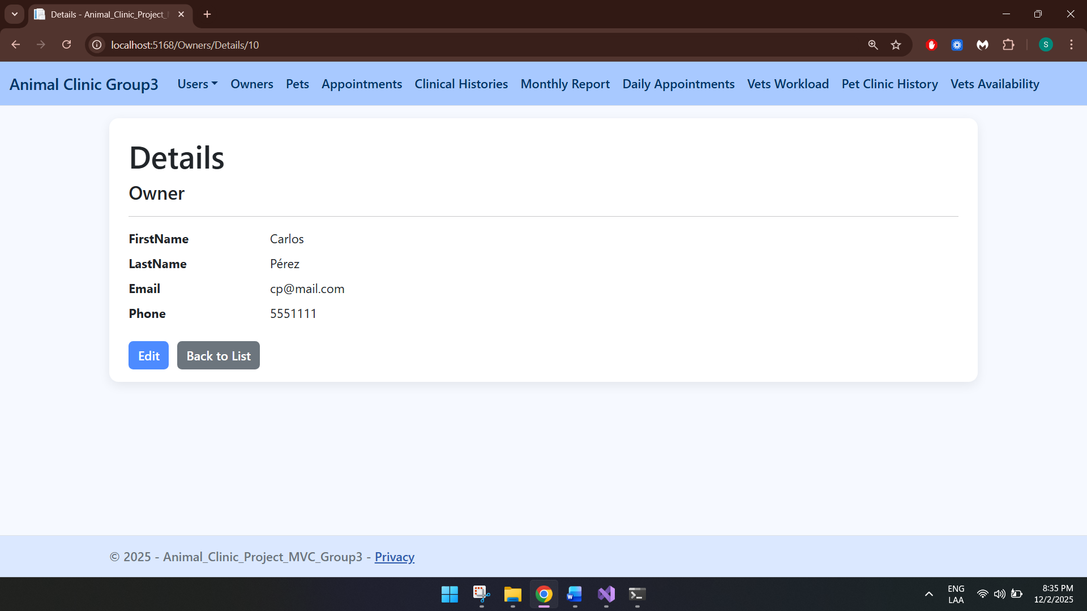

Delete
By clicking on Delete, a delete screen will open:
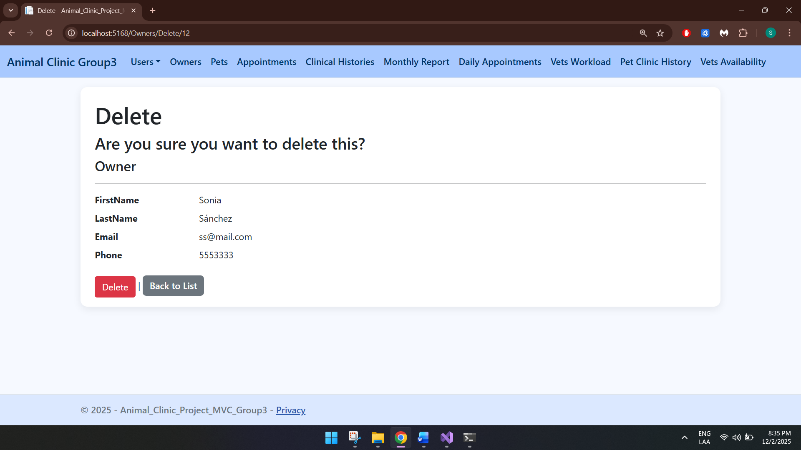

Pets
This table displays all pets:
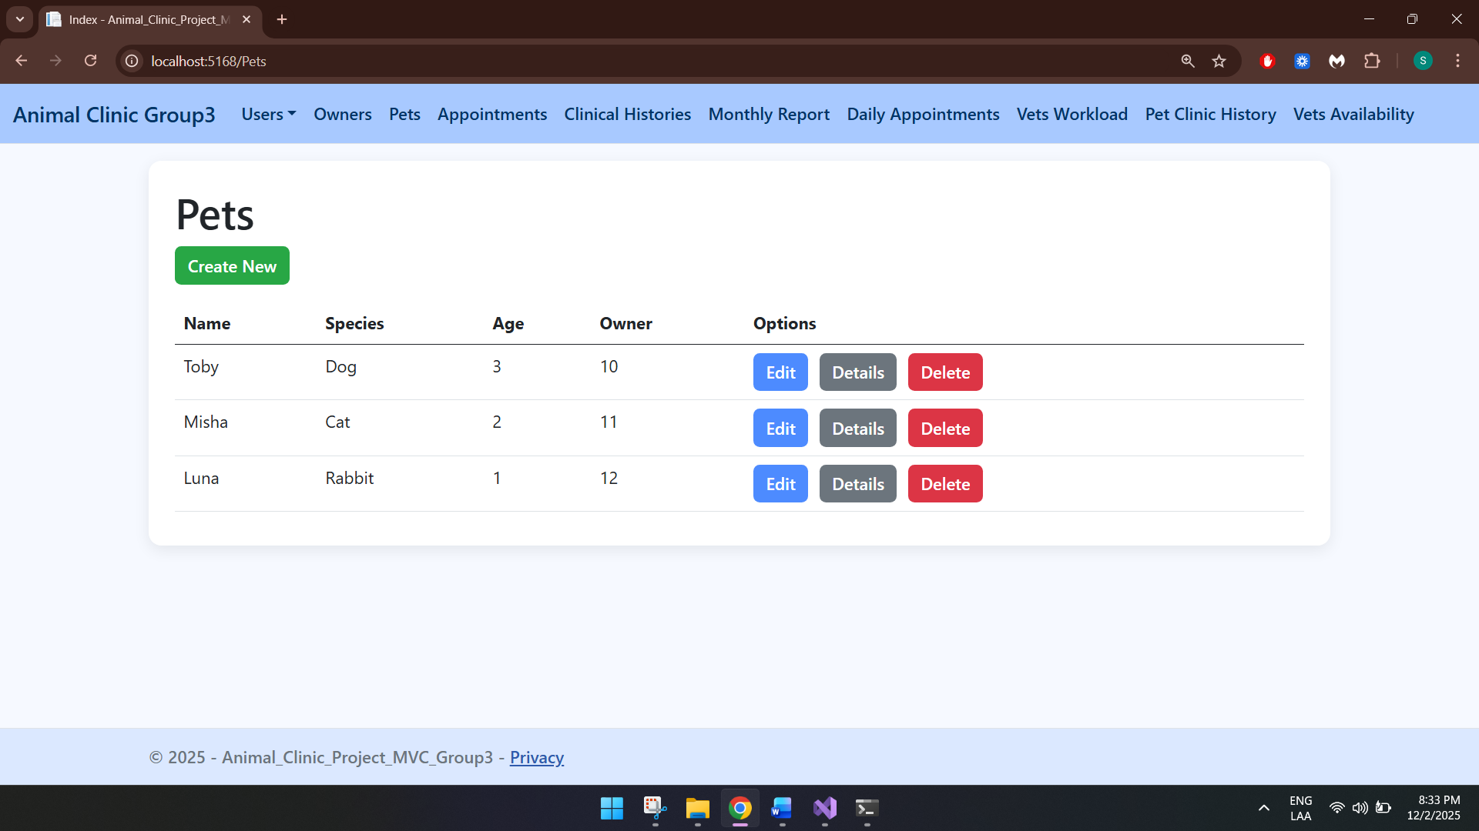

Create
By clicking on create new, a create pet screen will open:
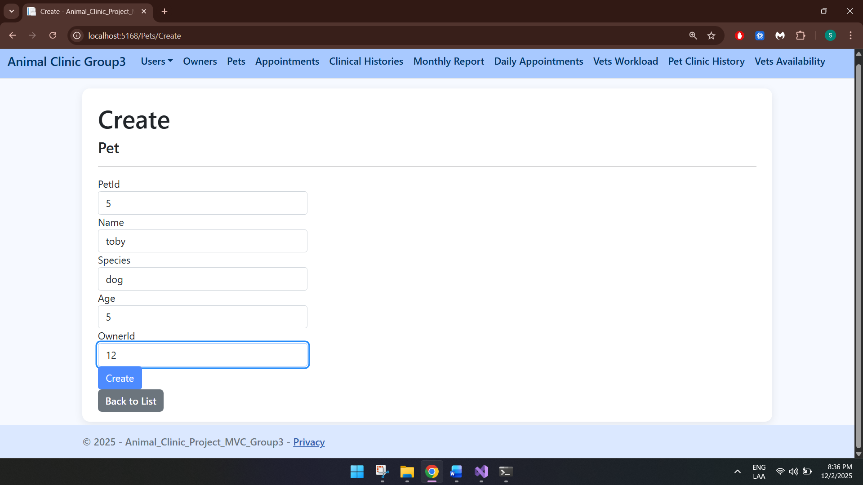

Edit
By clicking on Edit, a edit pet screen will open:
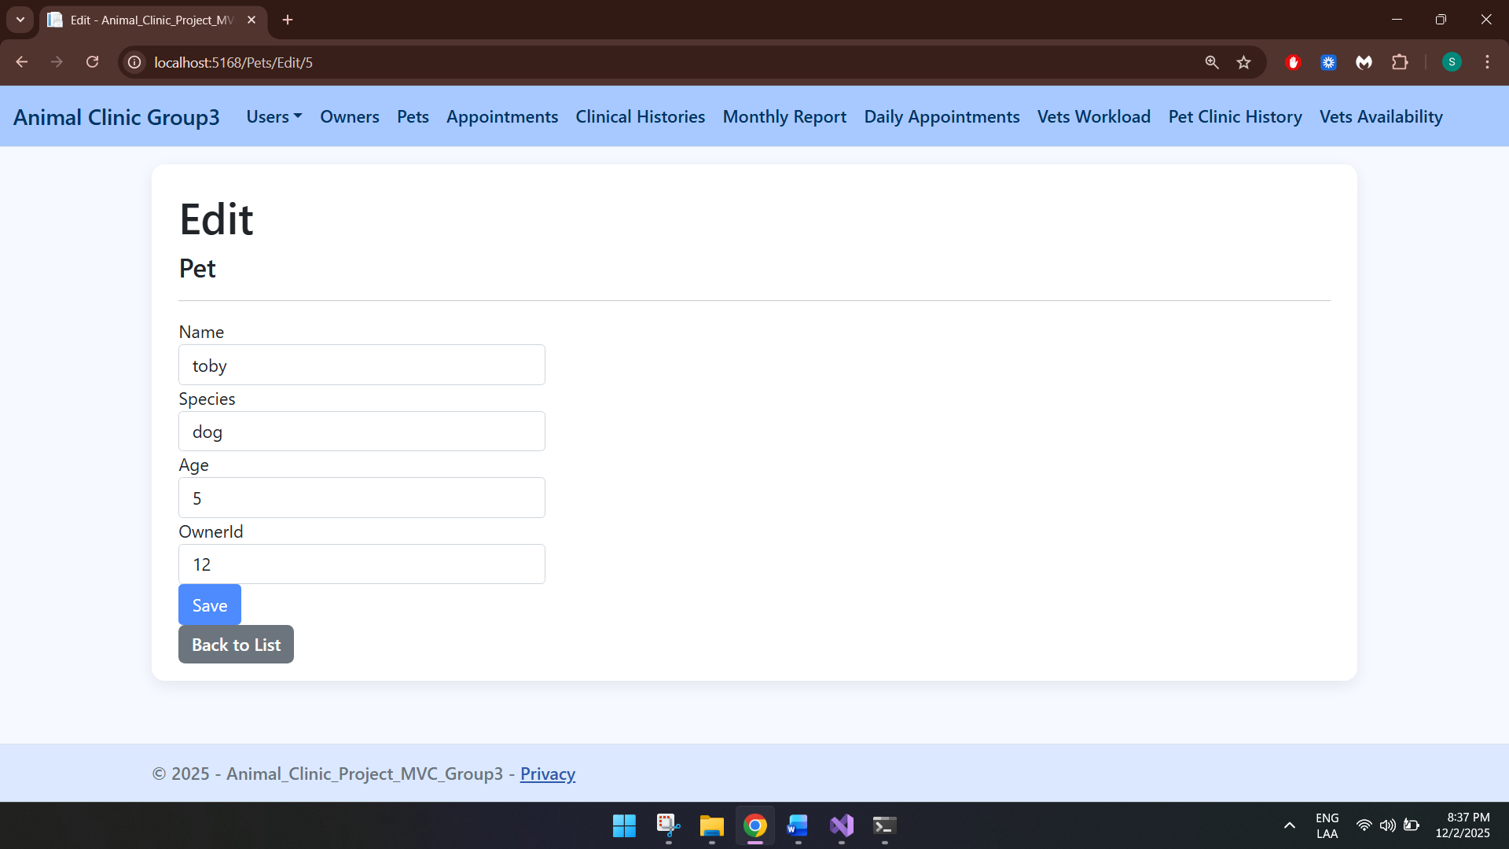

Details
By clicking on Details, a details screen will open:
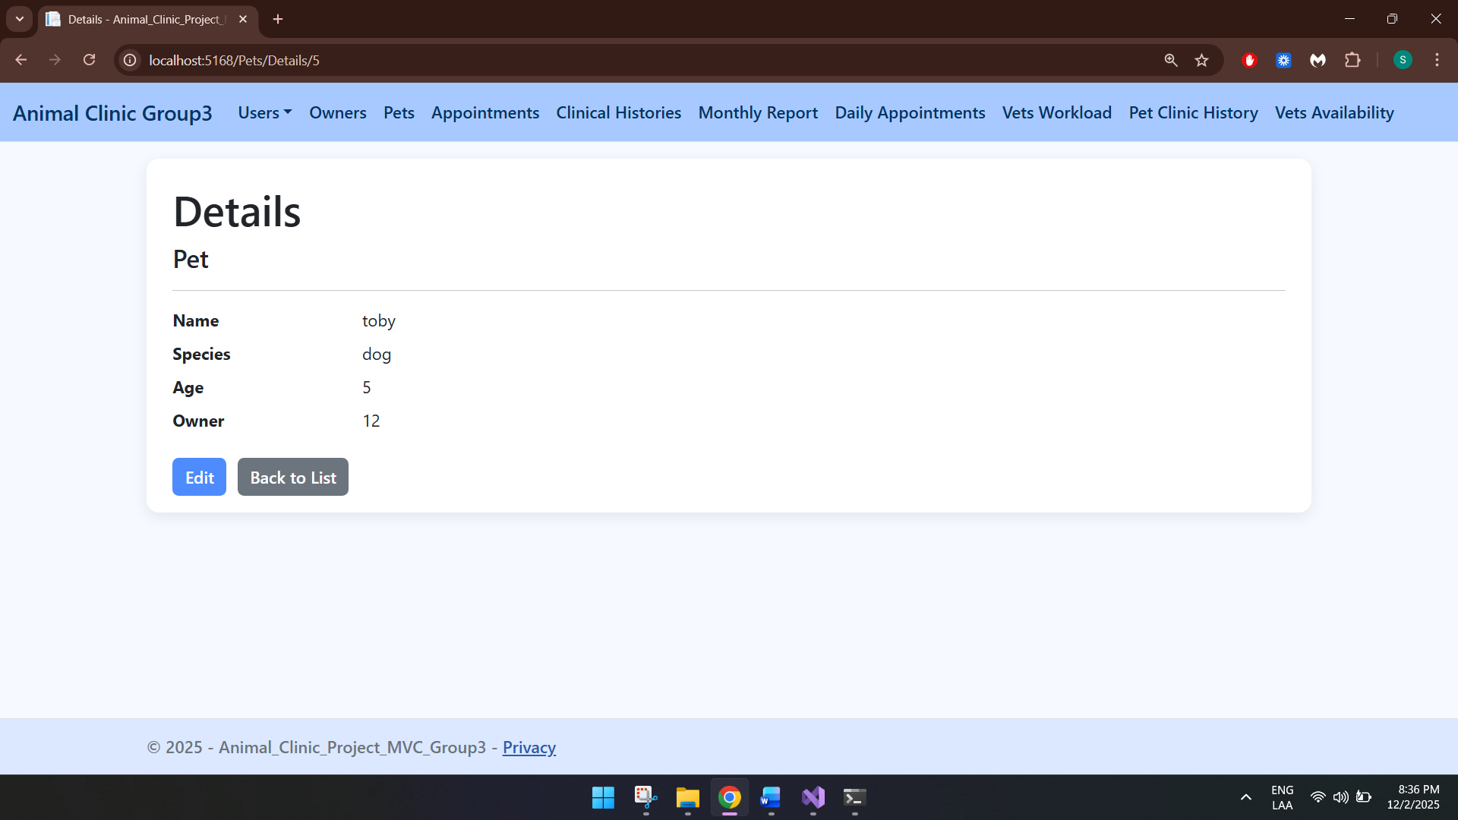

Delete
By clicking on Delete, a delete screen will open:
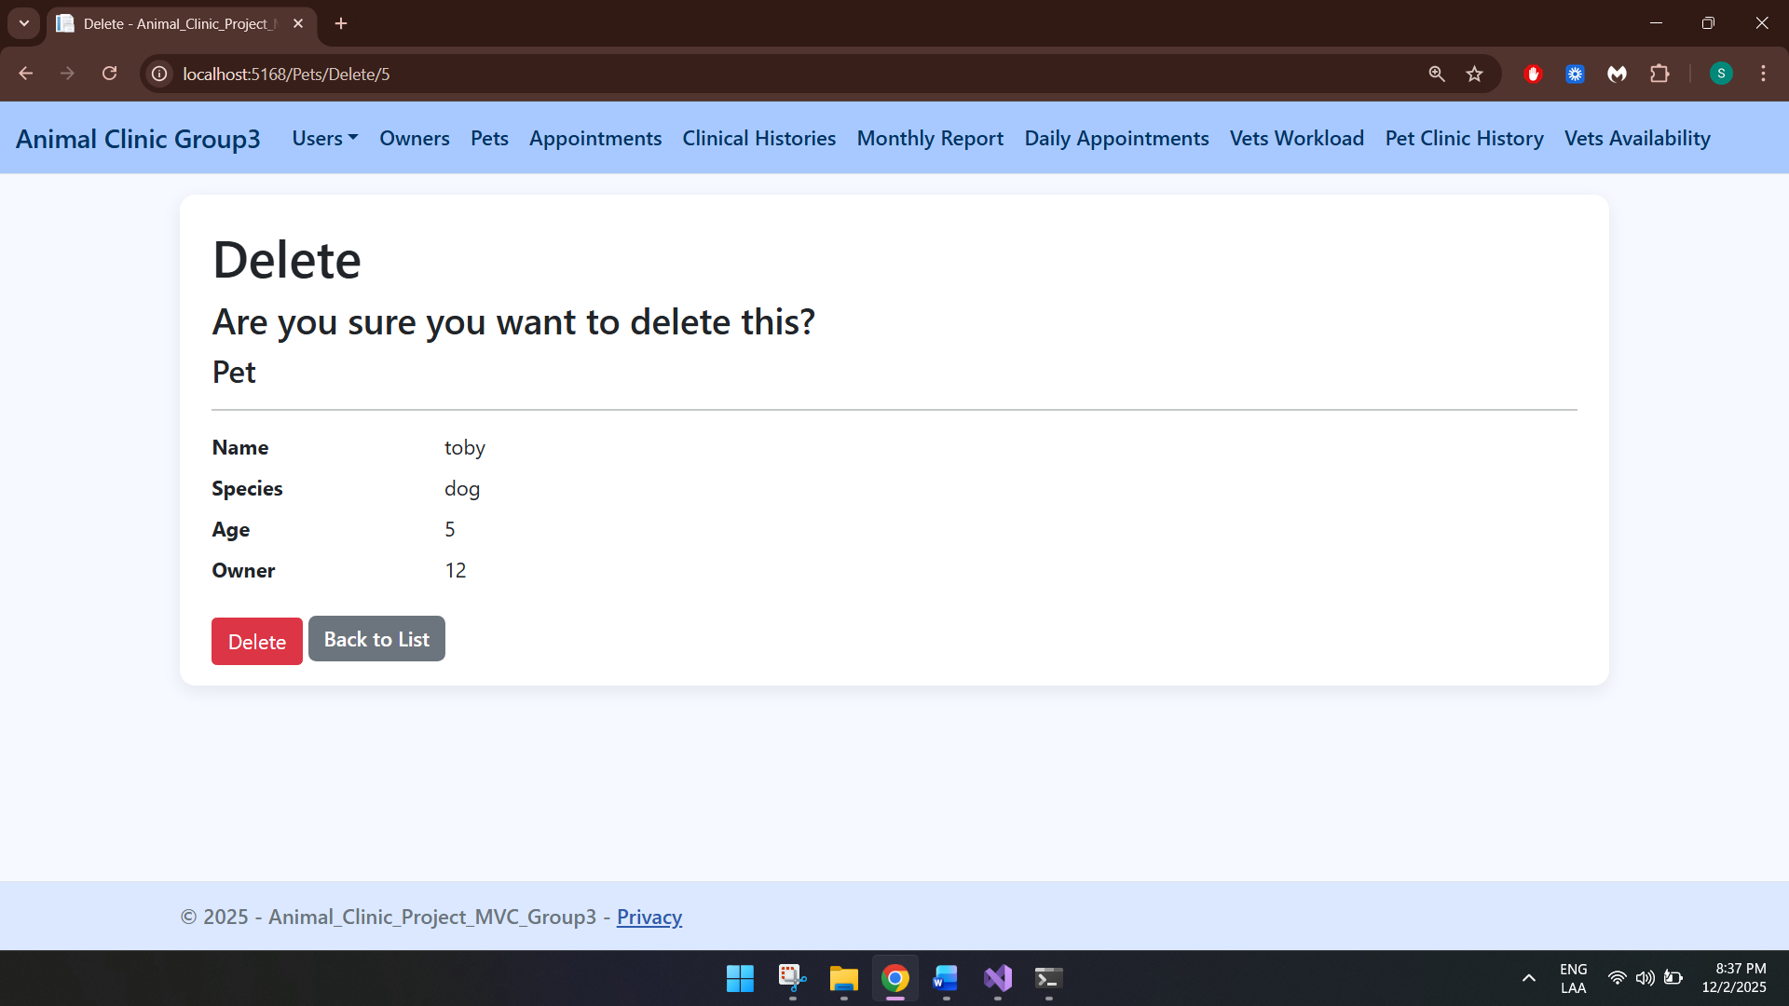

Appointments
This table displays all appointments:
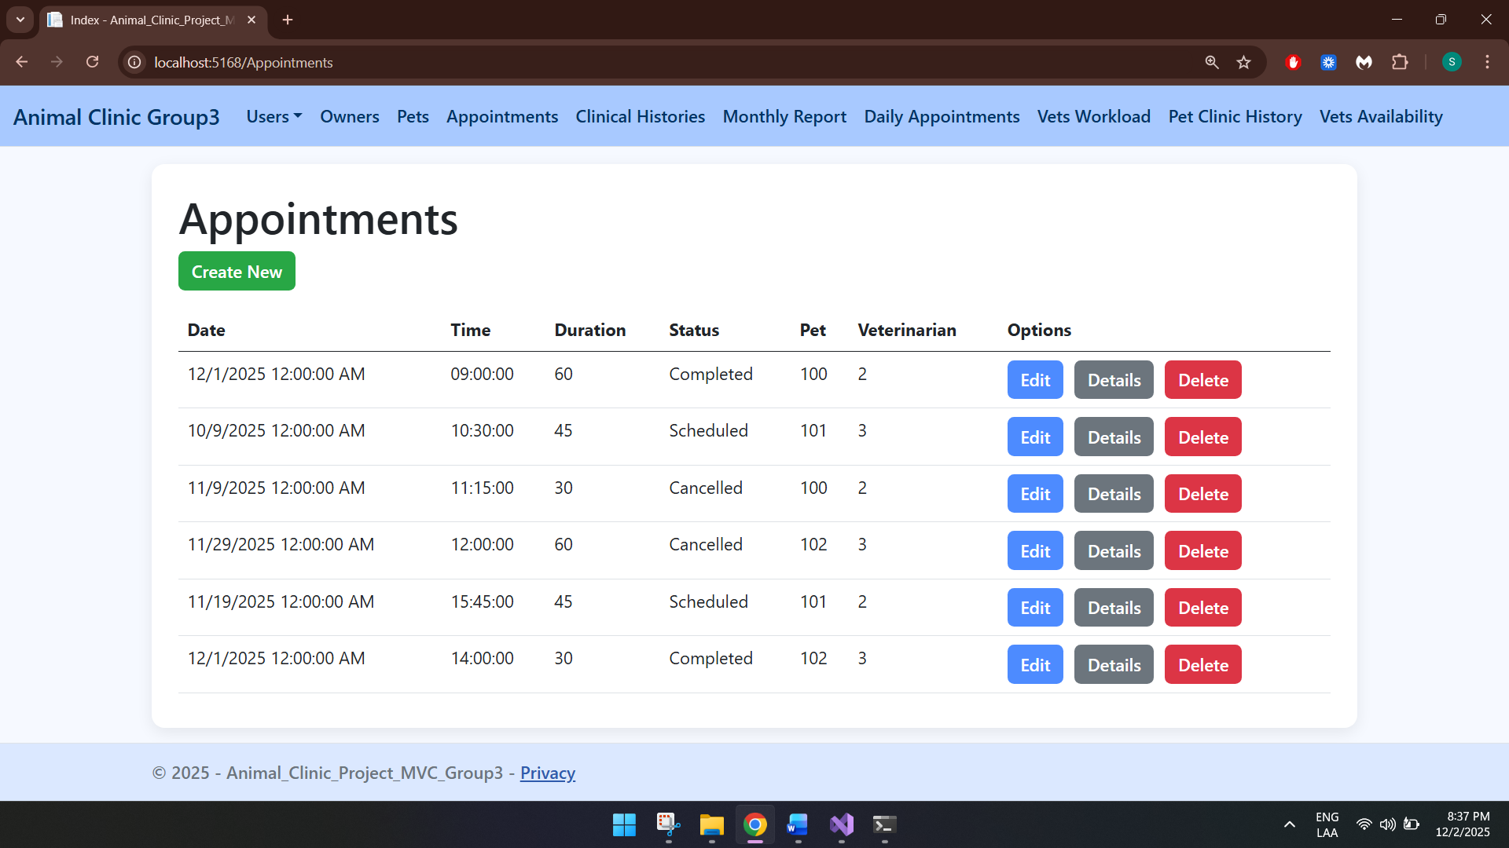

Create
By clicking on create new, a create appointment screen will open:
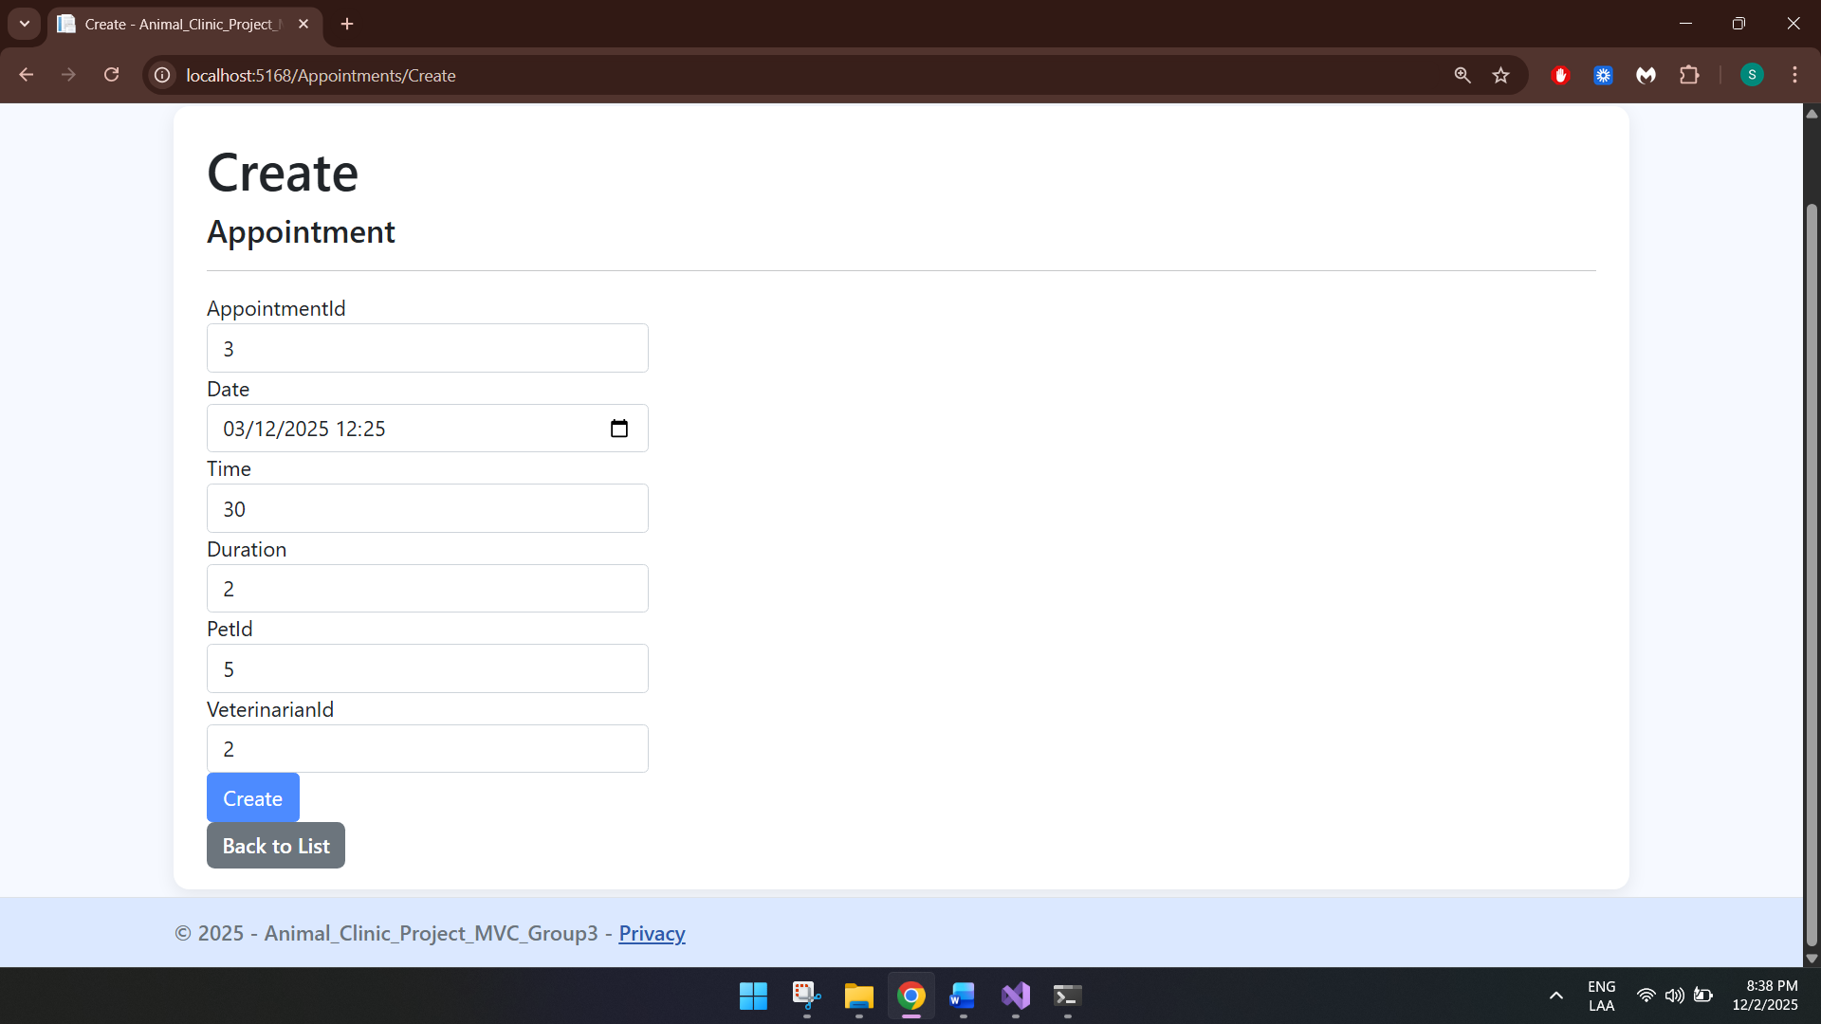

Edit
By clicking on Edit, a edit appointment screen will open:
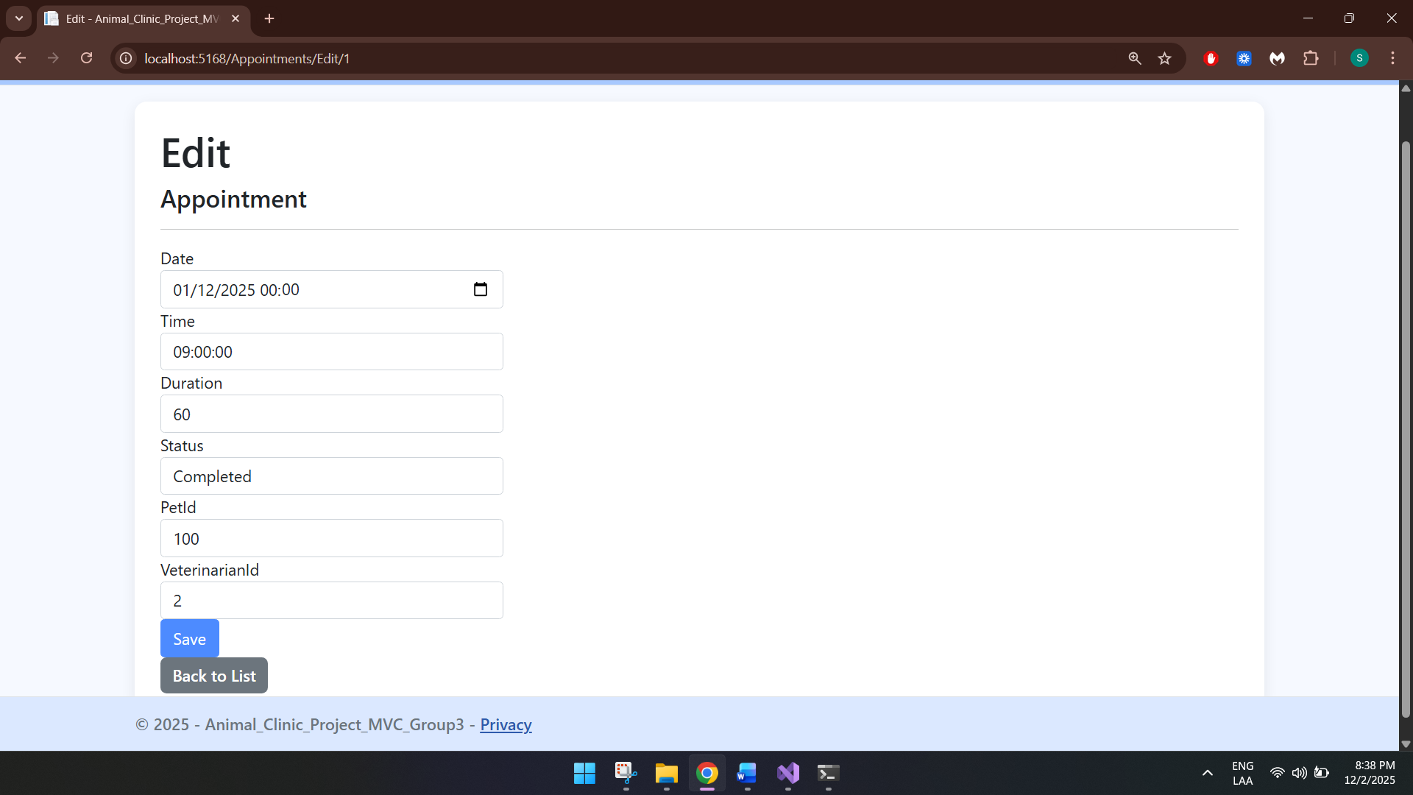

Details
By clicking on Details, a details screen will open:
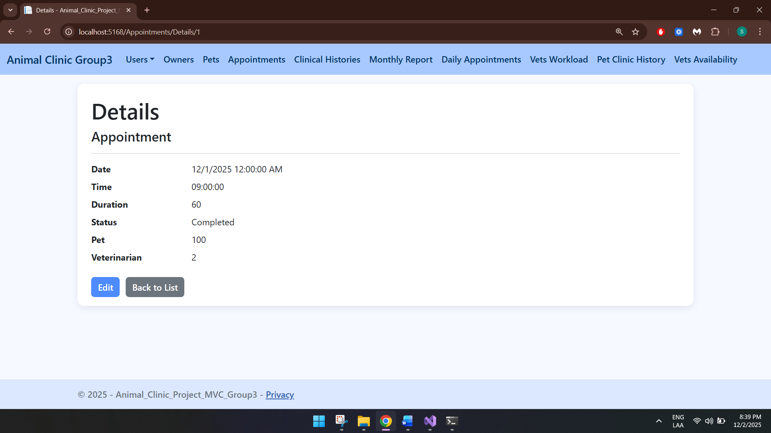

Delete
By clicking on Delete, a delete screen will open:
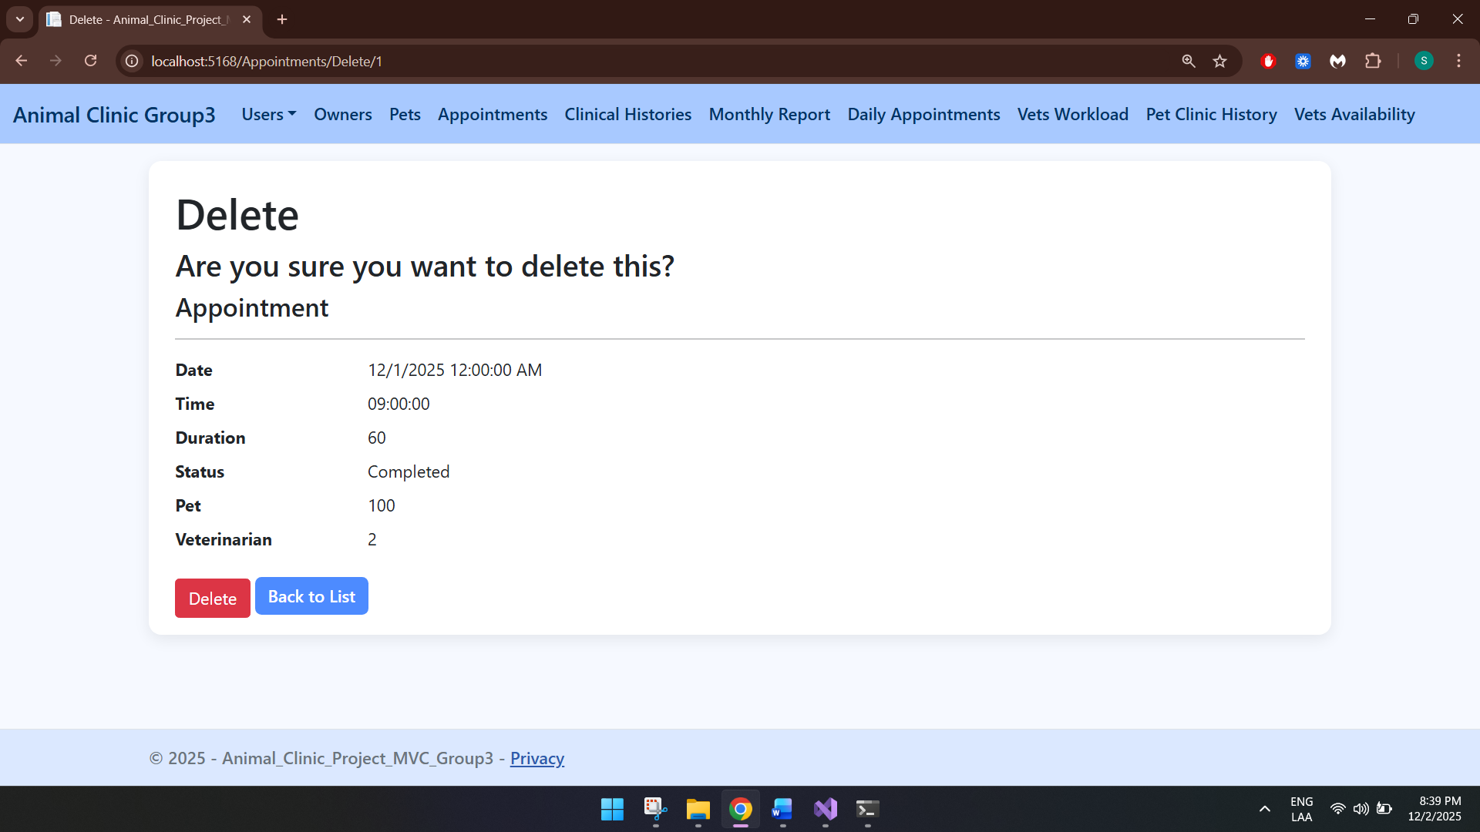

Clinical History
This table displays all clinical histories:
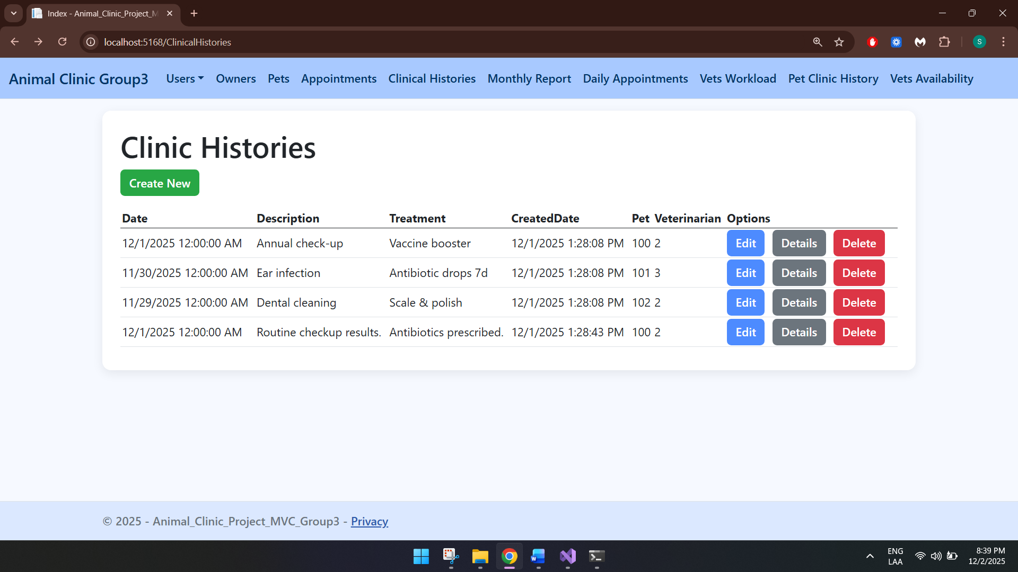

Create
By clicking on create new, a create appointment screen will open:
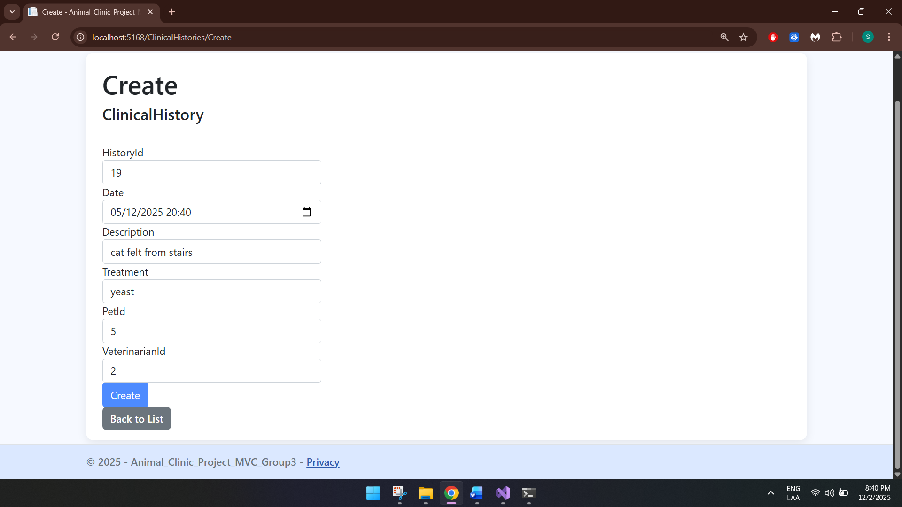

Edit
By clicking on Edit, a edit appointment screen will open:
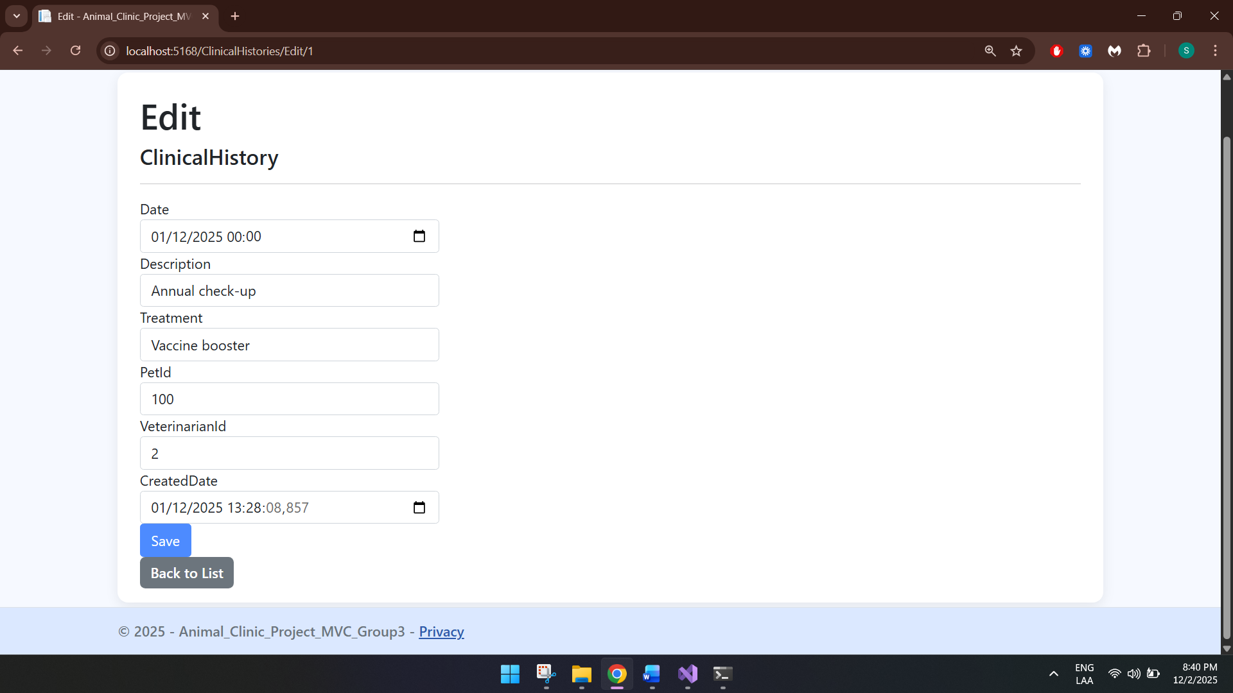

Details
By clicking on Details, a details screen will open:
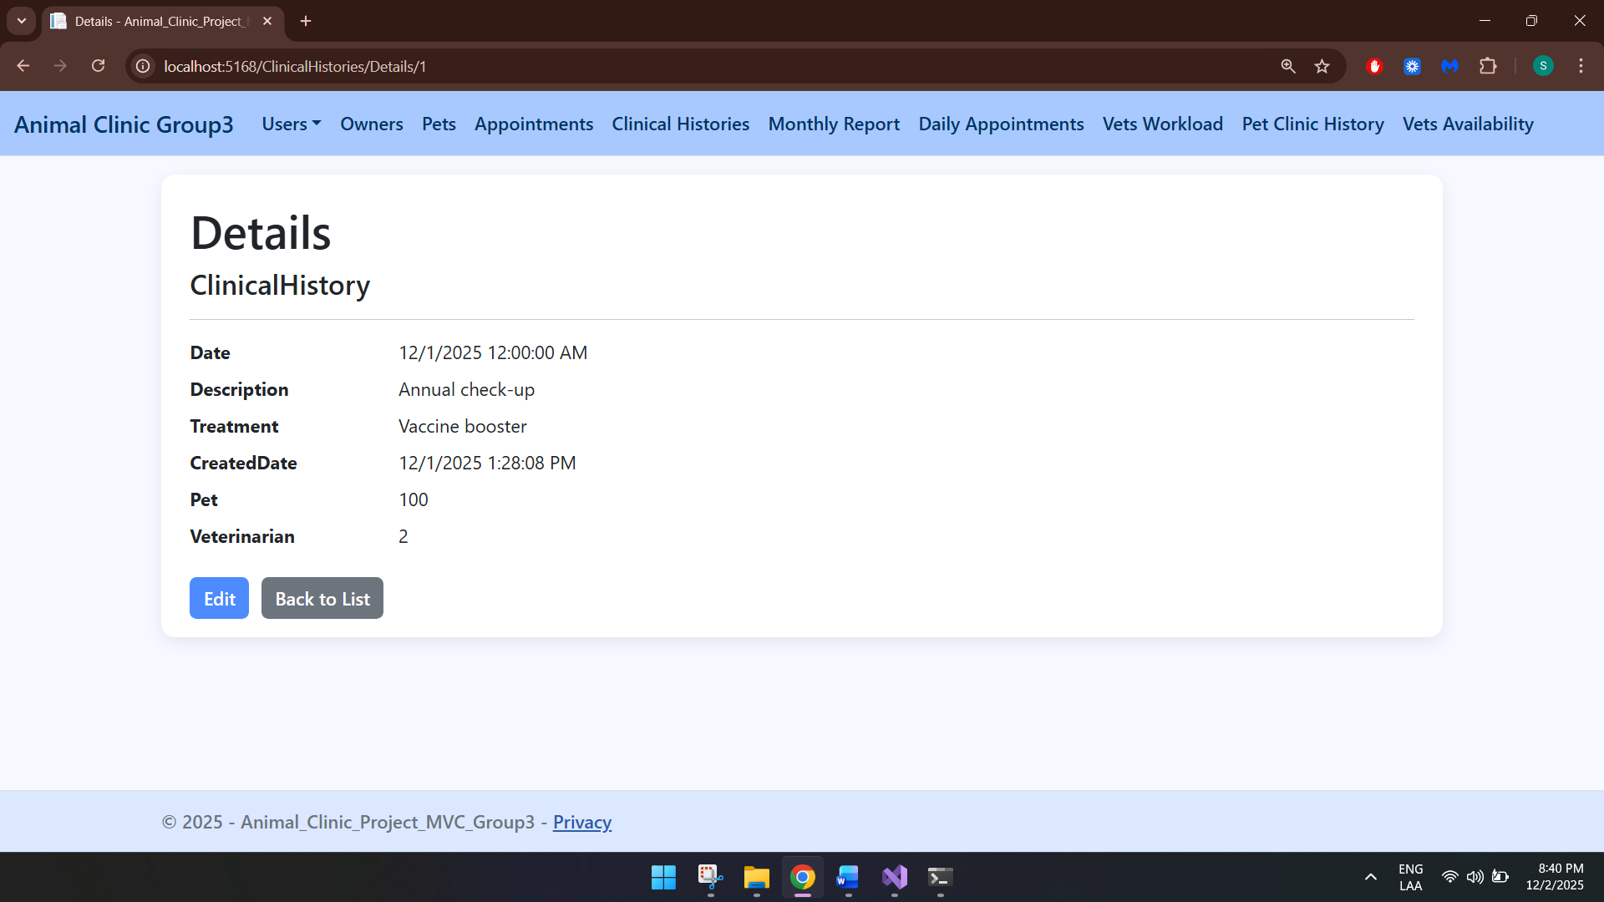

Delete
By clicking on Delete, a delete screen will open:
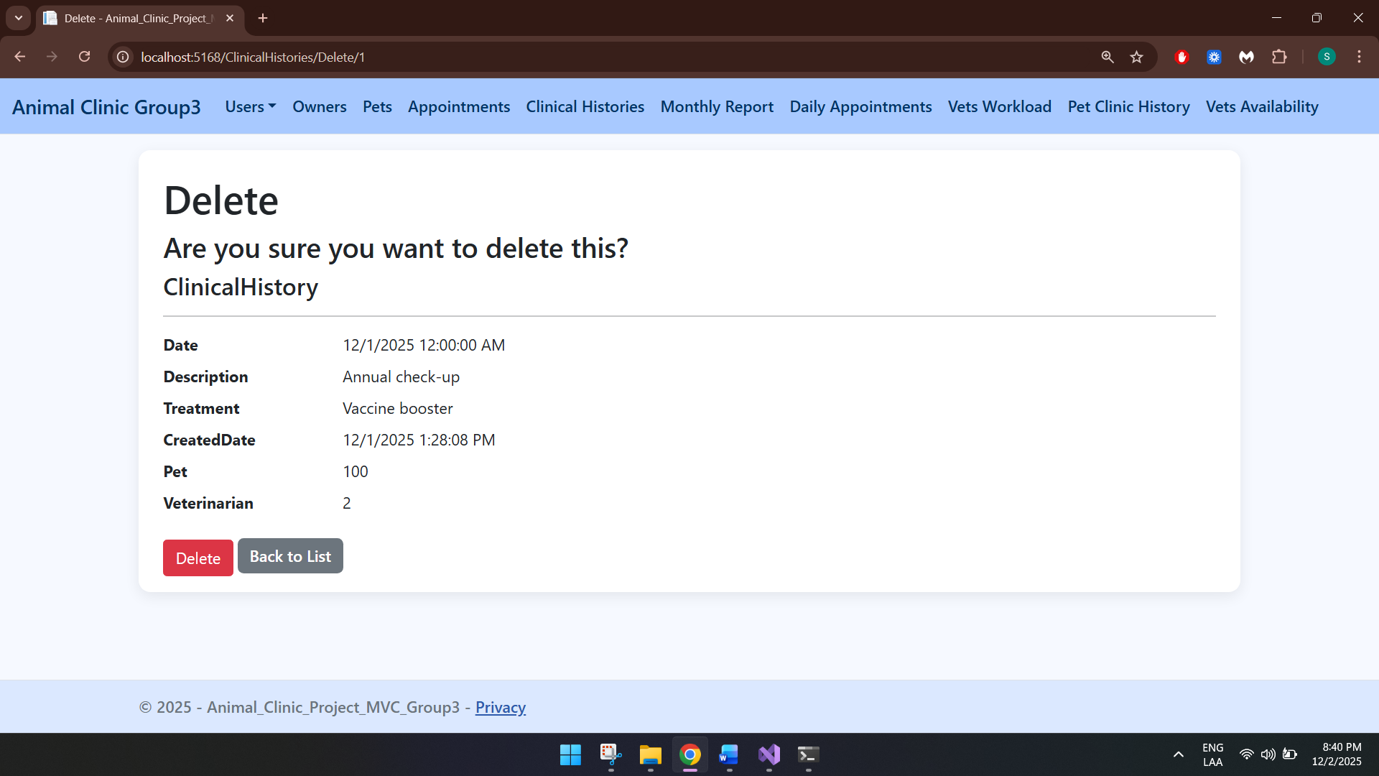

VIEWS

View All Users
This view displays all existing users, such as Administrators, Receptionist
and Veterinarians: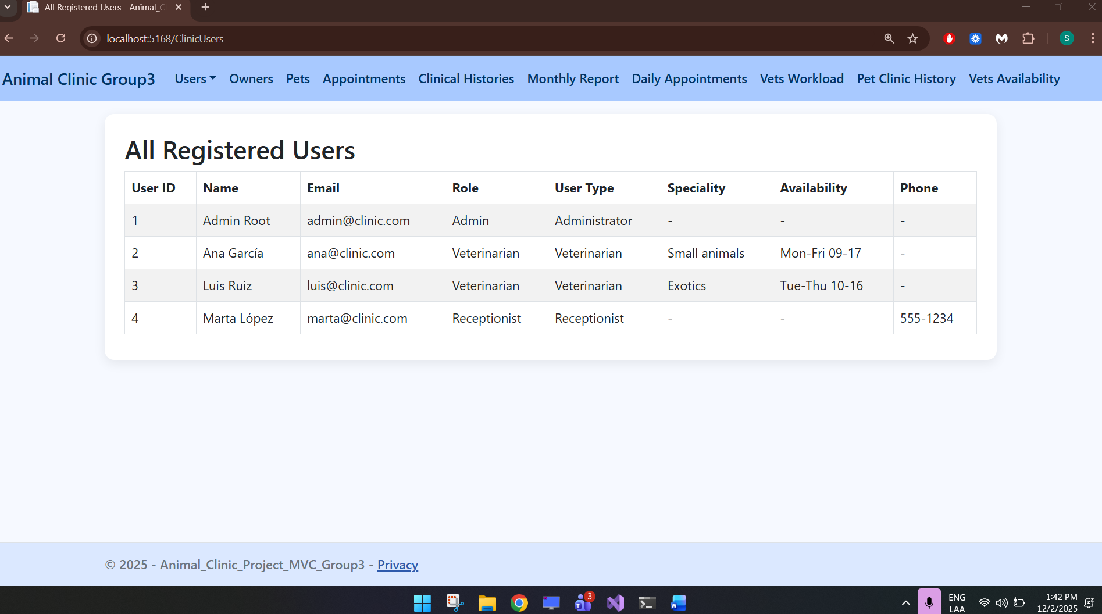

Appointments Agenda
This view displays the agenda with all the appointments, the vet, time, pet, owner and status of each appointment.
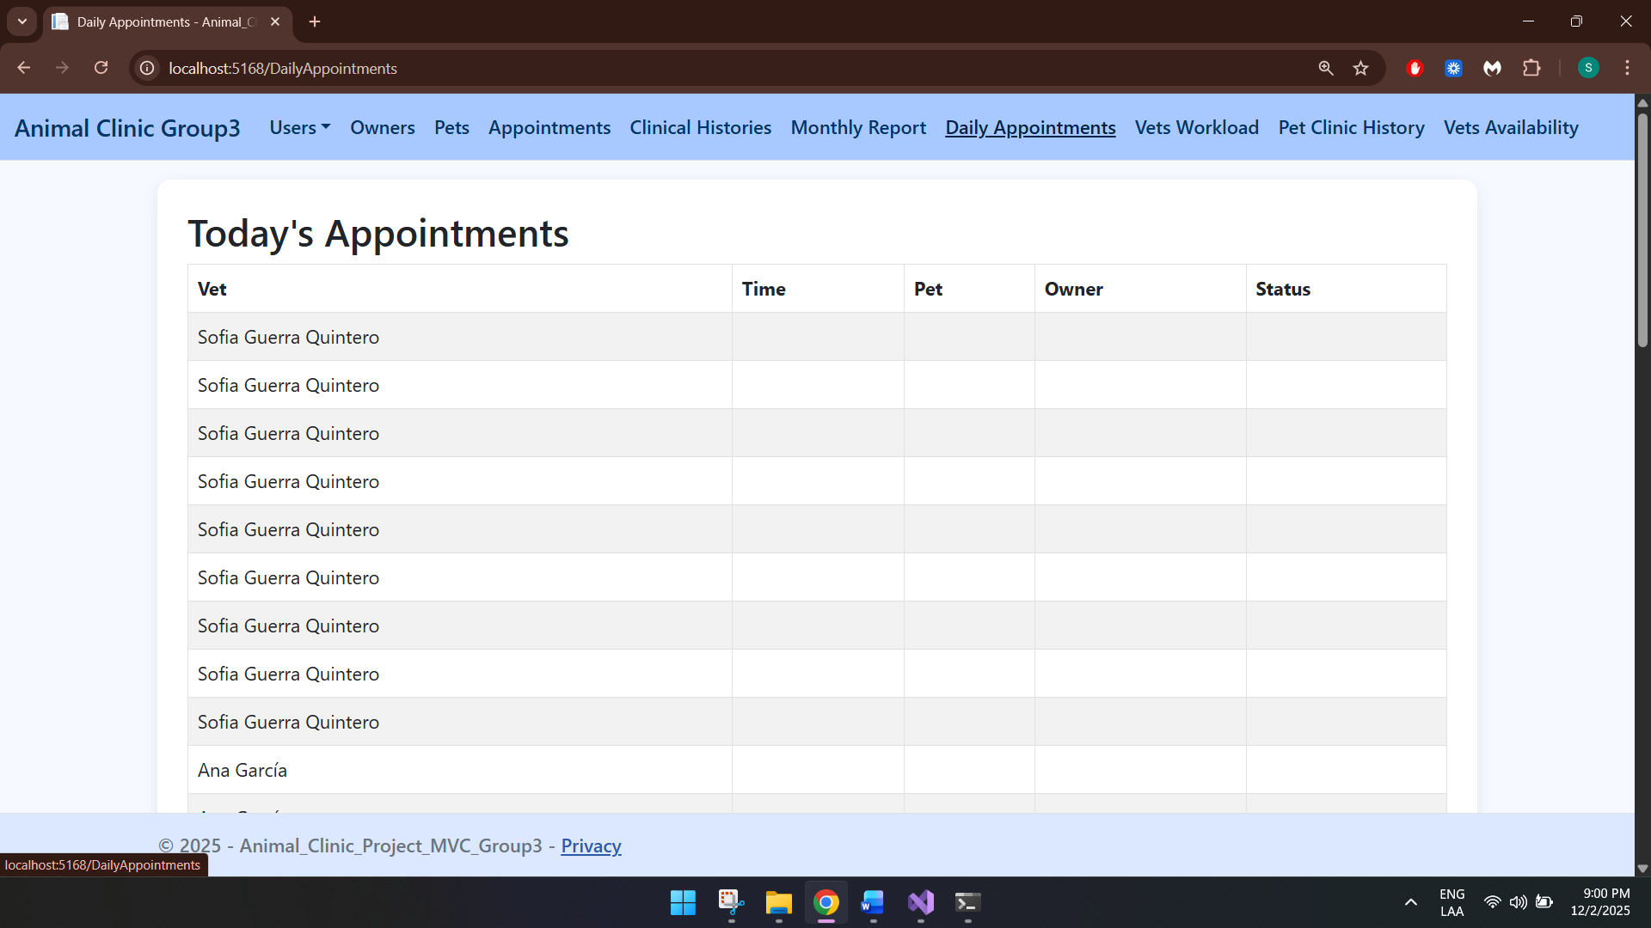

Monthly vet's workload
This view displays the vets workloads with all the appointments each vet has.
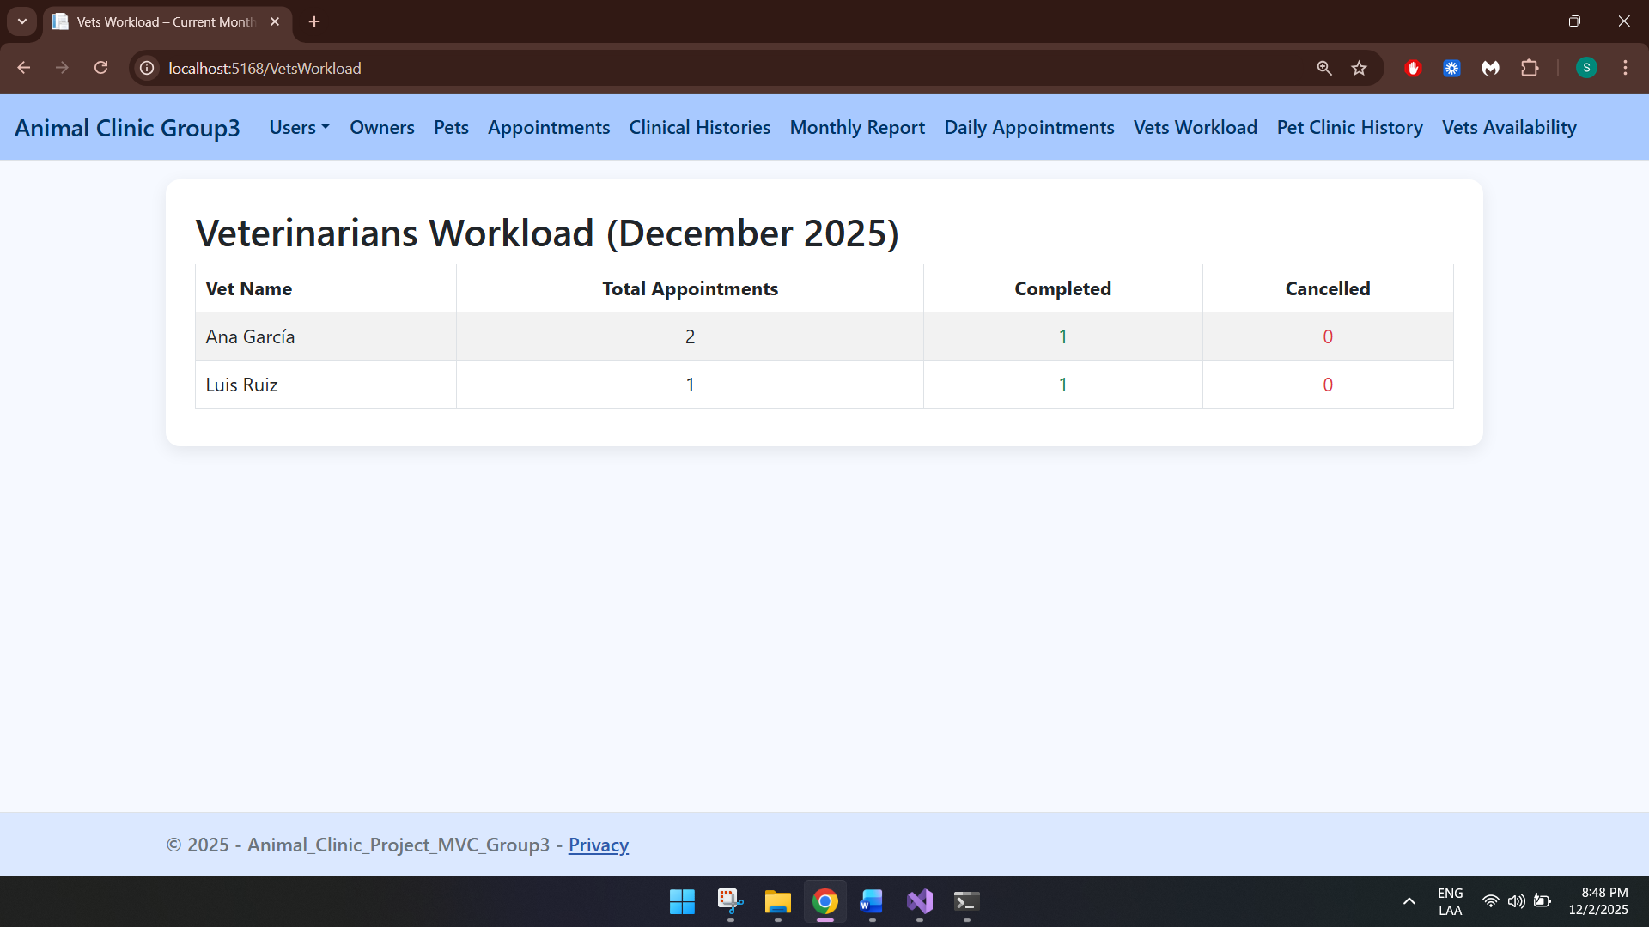

Clinic History
This view displays all the clinic history, including the specie, age, owner, date, description and treatment from each pet clinical history.
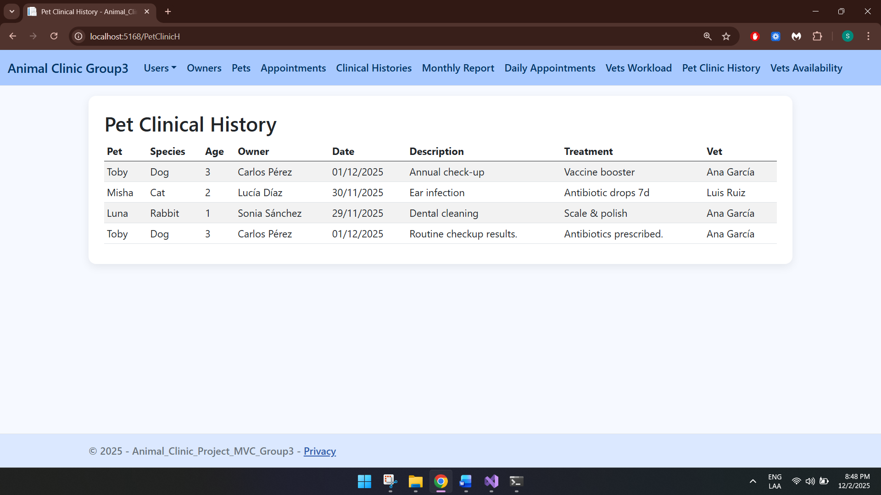

Slots Available
This view displays all the spots a veterinarian has available based on their disponibility.
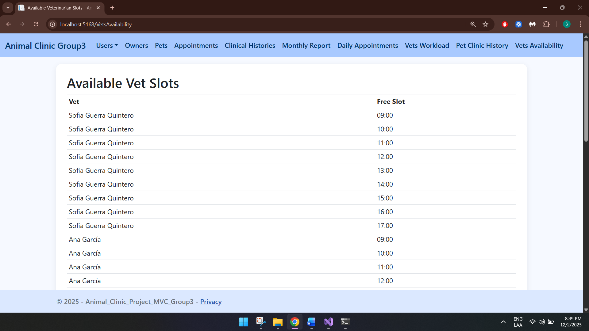

PROCEDURES

New appointment validation
Exception thrown when a new appointment is being created in a unavailable spot.
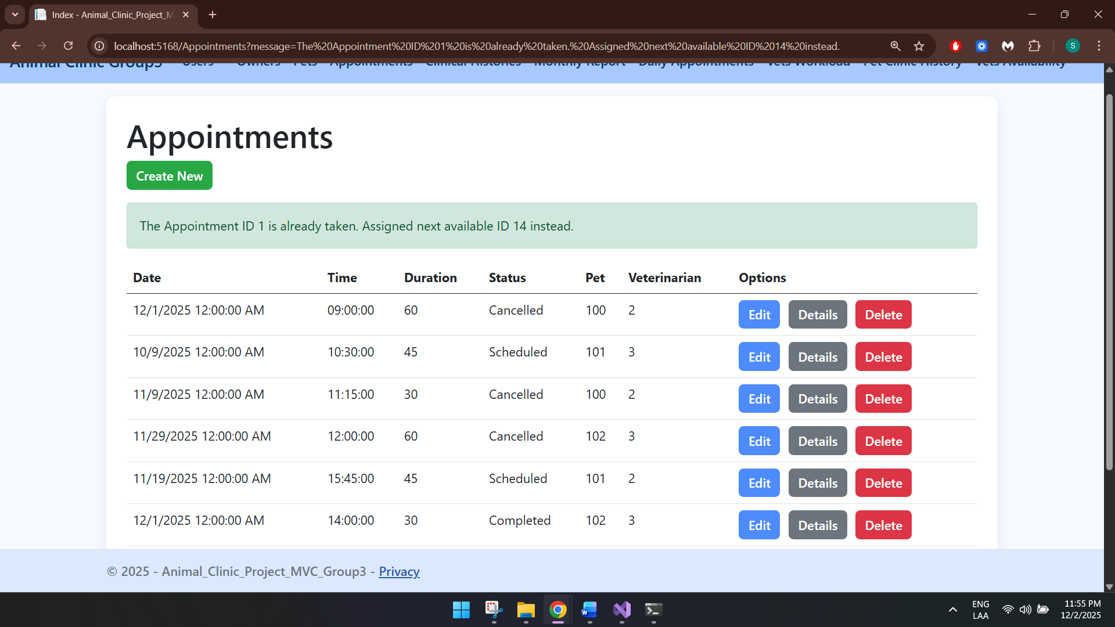

Cancel appointment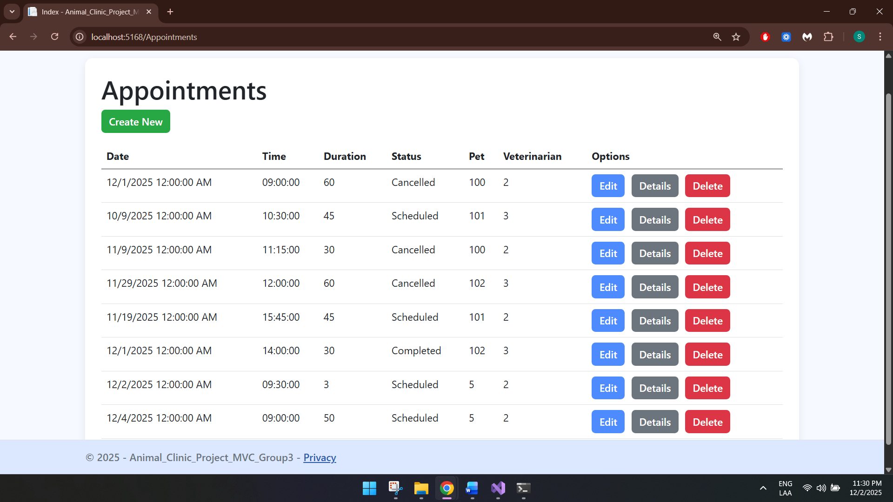

Monthly report
Generates the report based on completed and cancelled appointments.
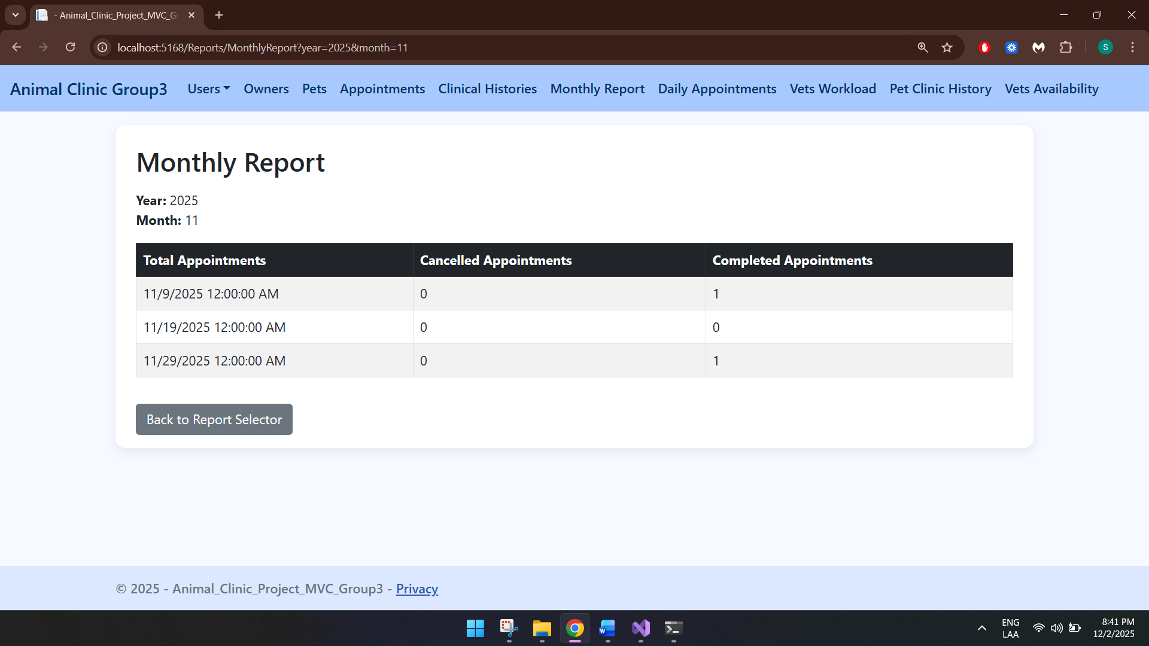

TRIGGERS

Prevent Past Appointments
This trigger prevents the user from setting appointments in past dates.
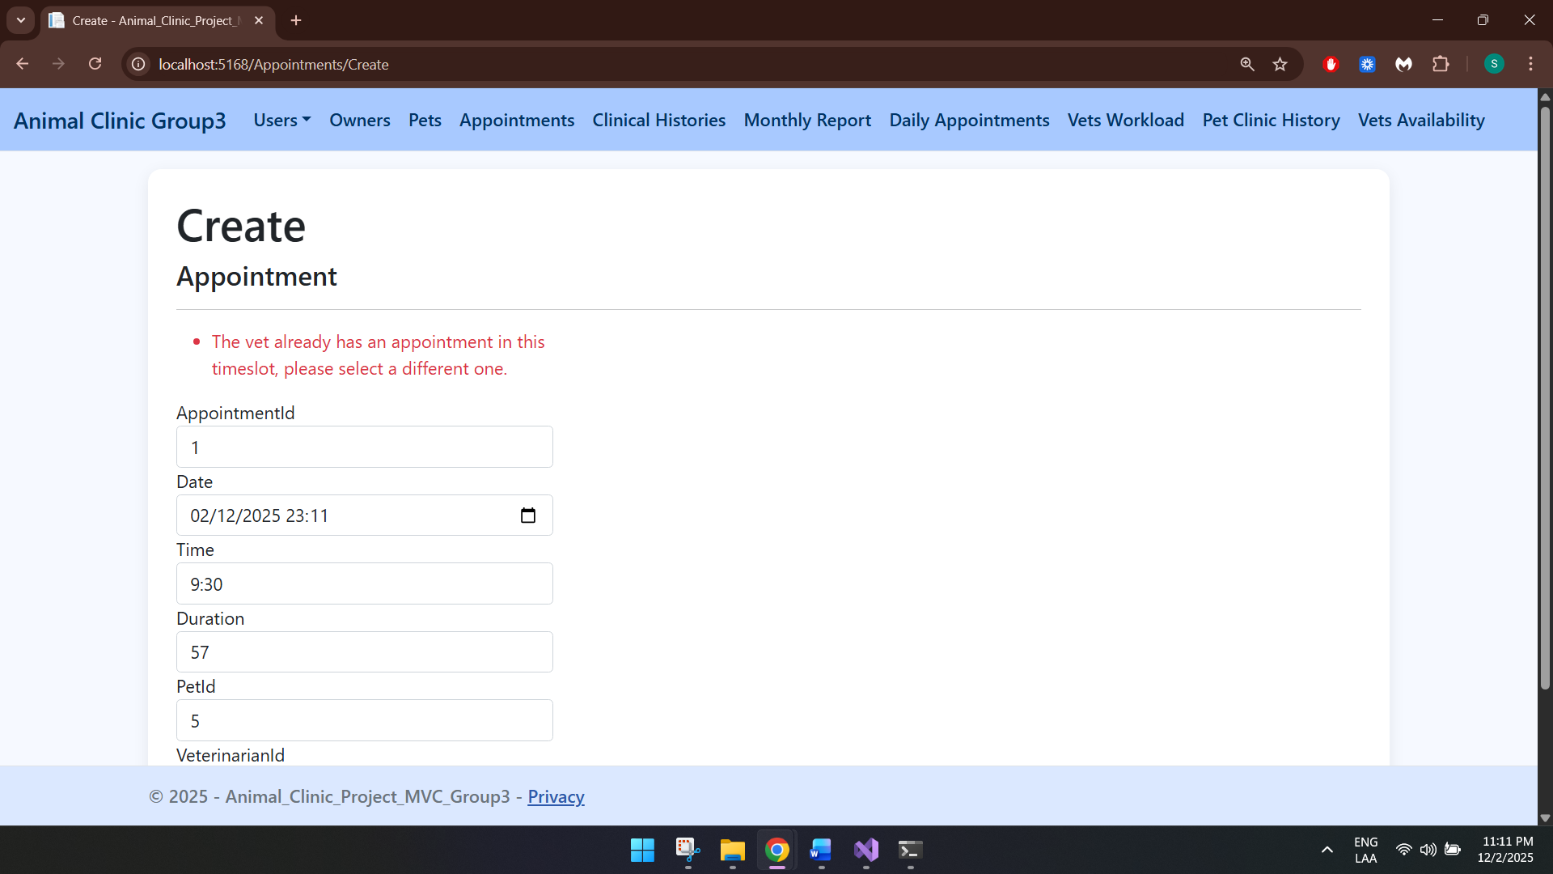

Cancel future appointments
This trigger cancels future appointments if a pet is deleted.


Cancel appointments after delete veterinarian
After deleting a veterinarian, all appointments will be cancelled as well.


Delete clinical history after delete pet
After deleting a pet, its clinical history will be deleted as well.
